**Chapter-1**   **Introduction of E-Commerce**

**1. Introduction**

**1.1 Overview**

**E-Commerce** is fast gaining ground as an accepted and used business paradigm. More and more business houses are implementing web sites providing functionality for performing commercial transactions over the web. It is reasonable to say that the process of shopping on the web is becoming commonplace. The objective of this project is to develop a general purpose e-commerce store where product like mobile, computer, gold, furniture and clothes can be bought from the comfort of home through the Internet. However, for implementation purposes, this paper will deal with an online shopping for many types of products. An online store is a virtual store on the Internet where customers can browse the catalogue and select products of interest. The selected items may be collected in a shopping cart. At checkout time, the items in the shopping cart will be presented as an order. At that time, more information will be needed to complete the transaction. Usually, the customer will be asked to fill or select a billing address, a shipping address, a shipping option, and payment information such as credit card number. An e-mail notification is sent to the customer as soon as the order is placed.

  An E-commerce website requires appropriate strategy of successful design and implementation. Everything is required to plan from scratch to end of website. The e-commerce sector is seen the exponential growth thus a new option will easily part of this regatta of commercial website. The E-Commerce website will feature the online shopping facility of various products under a single web space. The proposed web application will allow business personnel to make their total business using it and increase their reachability thousands of times more than today they have, over the internet. It will allow multiple shopping vendors to sale their products online. The product management in the system will be done in the form of categories. The safety of information is the main requirement of the system and will be handling according to that. To formulate this project first task is to do is cost estimation. For probabilistic assessment of the project cost estimation is required. Cost estimation covers the accurate; estimations of cost and effort required for the project.

As a project manager and developer as well, it’s is estimates are defined to early stage in the project. Cost estimation in application development project includes the set of procedures and techniques that will be utilized, required to produce by organisation for development. The available resources of a company are also affecting the cost estimation. It will be very complex project. To demonstrate knowledge learnt in class, tech communities and online materials, I will undertake the entire project alone even though it requires a team of four (4). It will take time of 6months to get the shape or get the basic structure. The environment variants depend on the further requirements of the ecommerce web application.

**1.2 Background of the Study**

The traditional marketing and management of fashion industry is experiencing a revolution because of the emergence of e-commerce. Since the birth of e-commerce, businesses have been able to make use of the Internet in reducing costs associated with purchasing, managing supplier relationships, streamlining logistics and inventory, and developing strategic advantage and successful implementation of business re-engineering. E-commerce allows companies to improve communications within the supply chain and enhance service offering, thus providing chances for competitive differentiation.

**1.3 Statement of the Problem**

Traditionally, customers are used to buying the products at the real, in other words, factual shops or supermarkets. It needs the customers to show up in the shops in person, and walk around different shopping shelves, and it also needs the owners of shops to stock, exhibit, and transfer the products required by customers. It takes labour, time and space to process these operations. Furthermore, the spread of the Covid-19 pandemic has caused a lot of changes in our lifestyle, people fearing to get outside their homes, transportation almost shut down and social distancing becoming all the more important. Big to small scale business that relied on the traditional incur a lot of consequence due to the lockdown issues. Some tend to more towards using social media platforms like Facebook to sell their product. However, the social media platforms have been beneficial for marketing purposes alone but leaves the whole task of customer and massive order management via direct messaging (DM), which takes a lot of time to respond to all customers. Addition, everyone tends to use social media, posing a great challenge to differentiate between scammers and legit sellers.

**1.4 The Solution**

Online shopping system provides a solution to reduce and optimize these expenses. Authorized Customers do not need to go to the factual shops to choose, and bring the products they need by hands. They simply browse their Personal computers or cell phones to access shops, and evaluate the products description, pictures on the screen to choose products. In addition, the owners of the shop do not need to arrange or exhibit their stocks products. They just input the description, prices of products, and upload their pictures. Simply, both customers and shop owners do not need to touch the real products in the whole process of shopping, and management. In the end the logistic centre will distribute the products required by customers, or products ordered by shop owners to their locations. The customers are able to track the status of their orders until delivery, after which they can leave a review of the type of service they received. The payment and products’ quantity will be saved in database through the data flow. These shopping, management and distribution processes greatly simplify and optimize the retail business.

**1.5 Aims and Objectives**

  The main objective of the study is to develop an E-commerce system. The system aims to achieve the following objectives:

* To design an online shopping system.
* To provides a solution to reduce and optimize the expenses of customer order management
* To create an avenue where people can shop for many products online.
* To develop a database to store information on many products and services.

**1.6 Scope and Limitation**

Every project is done to achieve a set of goals with some conditions keeping in mind that it should be easy to use, feasible and user friendly. As the goal of this project is to develop an online shopping system, this system will be designed keeping in mind the conditions (easy to use, feasibility and user friendly) stated above. It may help in effective and efficient order management. In every shot time, the collection will be obvious, simple and sensible. It is very possible to observe the customer potentials and purchase patterns because all the ordering history is store in the database. It is efficient managing all the operations of an online store within a single platform. The project aims to automate the business process of E-Commerce store. The proposed project would cover there are three roles available: Visitor, Customer and Admin.

**1.7 E-Commerce Project Module**

The application is implemented in PHP and consists of two main components:

**1.7.1 Visitor Module**

* Visitor can view available products without login.

**1.7.2** **Customer Module**

* Customer can view/search products without login.
* Customer can also add/remove product to cart with login (if customer try to add same product in cart. It will add only one)
* When customer try to purchase product, then he/she must login to system.
* After creating account and login to system, he/she can place order.
* If customer click on pay button, then their payment will be successful and their order will be placed.
* Customer can check their ordered details by clicking on orders button.
* Customer can see the order status (Pending, Confirmed, Delivered) for each order
* Customer can Download their order invoice for each order
* Customer can send feedback to admin (without login)

**1.7.3 Administrator Module**

* Admin can provide username, email, password and your admin account will be created.
* After login, there is a dashboard where admin can see how many customers is registered, how many products are there for sale, how many orders placed.
* Admin can add/delete/view/edit the category, sub-category and products.
* Admin can view/edit/delete customer details.
* Admin can view/delete orders.
* Admin can change status of order (order is pending, confirmed, out for delivery, delivered)
* Admin can ship order to user based on order placed by sending confirmation mail.

**1.8 Project Schedule**

An important skill for project managers is establishing a realistic timeline and making sure their team can meet project deadlines. A project management schedule can help track a project's progress and keep the team informed about tasks they have yet to complete.

A project schedule indicates what needs to be done, which resources must be utilized, and when the project is due. It's a timetable that outlines start and end dates and milestones that must be met for the project to be completed on time. The project schedule is often used in conjunction with a work breakdown structure (WBS) to distribute work among team members. The project schedule should be updated regularly to gain a better understanding of the project's status.

**1.8.1 Gantt Chart**

A Gantt chart is a type of bar chart, adapted by Karol Adamiecki in 1896 and independently by Henry Gantt in the 1910s, that illustrates a project schedule. Gantt charts illustrate the start and finish dates of the terminal elements and summary elements of a project. Terminal elements and summary elements comprise the work breakdown structure of the project. Modern Gantt charts also show the dependency (i.e., precedence network) relationships between activities. Gantt charts can be used to show current schedule status using percent-complete shadings and a vertical "TODAY" line as shown here.

Although now regarded as a common charting technique, Gantt charts were considered revolutionary when first introduced. This chart is also used in information technology to represent data that has been collected.  A Gantt chart is a horizontal bar chart developed as a production control tool in 1917 by Henry L. Gantt, an American engineer and social scientist. Frequently used in project management, a Gantt chart provides a graphical illustration of a schedule that helps to plan, coordinate, and track specific tasks in a project.  A Gantt chart, commonly used in project management, is one of the most popular and useful ways of showing activities (tasks or events) displayed against time. On the left of the chart is a list of the activities and along the top is a suitable time scale. Each activity is represented by a bar; the position and length of the bar reflects the start date, duration and end date of the activity. This allows you to see at a glance:

* What the various activities are.
* When each activity begins and ends.
* How long each activity is scheduled to last.
* Where activities overlap with other activities, and by how much.
* The start and end date of the whole project.
* To summarize, a Gantt chart shows you what has to be done

      (the activities) and when (the schedule).

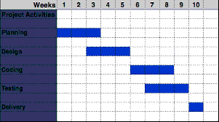

**Figure 1.1 Gantt chart**

**1.9.2** **Pert Chart**

  A PERT chart is a project management tool used to schedule, organize and coordinate tasks within a project. A similar methodology, the Critical Path Method (CPM) was developed for project management in the private sector at about the same time.

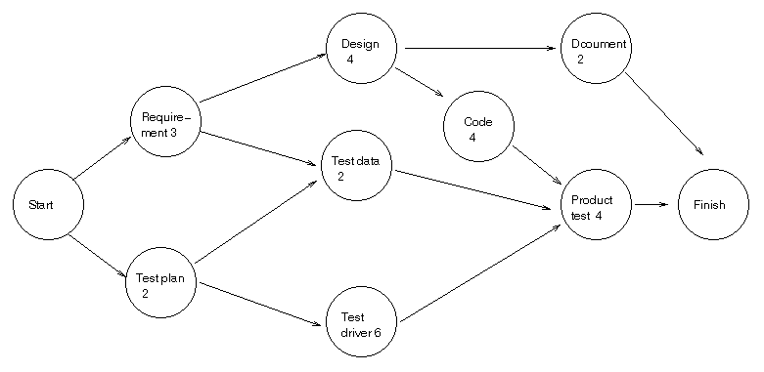

A PERT chart presents a graphic illustration of a project as a network diagram consisting of numbered nodes (either circles or rectangles) representing events, or milestones in the project linked by labeled vectors (directional lines) representing tasks in the project. The direction of the arrows on the lines indicates the sequence of tasks. In the diagram, for example, the tasks between nodes 1, 2, 4, 8, and 10 must be completed in sequence. These are called dependent or serial tasks. The tasks between nodes 1 and 2, and nodes 1 and 3 are not dependent on the completion of one to start the other and can be undertaken simultaneously.

The PERT chart is sometimes preferred over the Gantt chart, another popular project management charting method, because it clearly illustrates task dependencies. On the other hand, the PERT chart can be much more difficult to interpret, especially on complex projects. Frequently, project managers use both techniques.

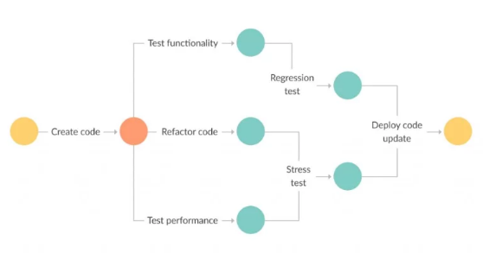

**Fig.1.2 Pert Chart**

Chapter -2

**System Analysis and Design**

**2.  System Analysis**

Systems Analysis is a broad term for describing methodologies for developing high quality Information System which combines Information Technology, people and Data to support business requirement. The SAD technique is not only limited to IT systems and can be used to create just about anything. It is a process of collecting and interpreting facts, identifying the problems, and decomposition of a system into its components. It is a problem solving technique that improves the system and ensures that all the components of the system work efficiently to accomplish their purpose.

It is a process of planning a new business system or replacing an existing system by defining its components or modules to satisfy the specific requirements. Before planning, you need to understand the old system thoroughly and determine how computers can best be used in order to operate efficiently.

**2.1   Feasibility Study**

Whatever we think need not be feasible .It is wise to think about the feasibility of any problem we undertake. Feasibility is the study of impact, which happens in the organization by the development of a system. The impact can be either positive or negative. When the positives nominate the negatives, then the system is considered feasible. Here the feasibility study can be performed in two ways such as technical feasibility and Economical Feasibility.

All projects are feasible when given unlimited resources and infinite time. Its both necessary and prudent to evaluate the feasibility of a project at the earliest possible time. The efforts and resources spent in developing the system will be a waste if the end solution does not offer timely and satisfactory solution to its users. Feasibility study is a test of system proposed regarding workability, impact on the organization ability to meet user needs, and effective use of resources. Thus when a new application is proposed, it normally goes through a feasibility study before it is approved for development. Feasibility and risk analysis are related in many ways. If project risk is great, the possibility of producing quality software is reduced.

**2.1.1 Operational Feasibility**

People are inherently resistant to change, and computers have been known to facilitate change. An estimate should be made of how strong a reaction the user staff is likely to have toward the development of a computerized system. It is common knowledge that computer installations have something to do with turnover, transfers, retraining, and changes in employee job status. Therefore, it is understood that the introduction of a candidate system requires special effort to educate, sell and train the staff on new ways of conducting business.

**2.1.2 Technical Feasibility**

Technical feasibility centers around the existing computer system (hardware, software, etc.) and to what extend it can support the proposed addition. For example, if the current computer is operating at 80 percent capacity – an arbitrary ceiling – then running another application could overload the system or require additional hardware. This involves financial considerations to accommodate technical enhancements. If the budget is a serious constraint, then the project is judged not feasible.

**2.1.3 Cost/ Benefit Analysis**

Economic analysis is the most frequently used method for evaluating the effectiveness of a candidate system. More commonly known as cost benefit analysis, the procedure is to determine the benefits and savings that are expected from a candidate system and compare them with costs. If benefits overweigh costs, then the decision is made to design and implement the system. Otherwise, further justification or alterations in the proposed system will have to be made if it is to have a chance of being approved. This is an ongoing effort that improves in accuracy at each phase in the system life cycle.

**2.1.4 Economical Feasibility**

  The proposed system insures very low cost for the development and implementation. The system can work on systems with a configuration and connectivity which causes no excessive cost for implementation or usage. Data charge is the only cost that incurred once the software is installed on the system. The study is carried out to check the economic impact that the system will have on the organization. The amount of fund that the company can pour into the research and development is limited. The expenditure must be justified. Thus the developed system as well within the budget and this was achieved because most of the technologies used are freely available. Only the customized products had to be purchased. All you really need to do is install the software on your system and activate it.

**2.2 Requirement Specification**

This is the very first phase of Software testing Life cycle. In this phase testing team goes through the Requirement document with both Functional and non-functional details in order to identify the testable requirements. In case of any confusion the QA team may setup a meeting with the clients and the stakeholders (Technical Leads, Business Analyst, System Architects and Client etc.) in order to clarify their doubts. Once the QA team is clear with the requirements they will document the acceptance Criteria and get it approved by the Customers.

**2.2.1 Hardware Specification**

            Processor : i3 2.83Ghz

Memory : 1GB

Hard Disk : 80GB

Monitor : 14’’ or above

Mouse : Standard Mouse

Key Board : 104 keys

**2.2.2 Software Specification**

                    Operating System **:**  WINDOWS 2008/2010

                     Programming Language  **:**        HTML/JS/CSS/PHP/BOOTSTRAP

                       Database                       **:**        MYSQL

**2.3 Development Technology Description**

The development technology is the set of processes and programming tools used to create the program or software product. The term may sometimes also imply the physical environment. An integrated development environment is one in which the processes and tools are coordinated to provide developers an orderly interface to and convenient view of the development process or at least the processes of writing code, testing it, and packaging it for use.

**2.3.1 HTML**

HTML stands for HYPER TEXT MARKUP LANGUAGE, which is most widely used language on web to develop web pages. HTML refers to the way in which Web pages (HTML documents) are linked together. Thus, the link available on a web page is called Hypertext. HTML was created by Berners-Lee in late 1991 but “HTML 2.0” was the first standard HTML specification which was published in 1995. HTML 4.01 was a major version of HTML and it was published in late 1999. Though HTML 4.01 version is widely used but currently we are having HTML-5 version which is an extension to HTML 4.01, and this version was published in 2012.

 As its name suggests, HTML is a Mark-up Language which means you use HTML to simply “mark-up” a text document with tags that tells a web browser how to structure it to display. Originally, HTML was develop with the intent of defining the structure of documents like heading, paragraph, lists, and so forth to facilitate the sharing of scientific information between researchers. Now, HTML is being widely used to format web pages with the help of different tags available in HTML.

**2.3.2 CSS**

Cascading Style Sheet is a style sheet language used for describing the presentation of a document written in a markup language Although most often used to set the visual style of web page and user interfaces written in HTML and XHTML, the language can be applied to any XML document, including plain XML, SVG and XUL, and is applicable to rendering in speech, or on other media. Along with HTML and JavaScript, CSS is a cornerstone technology used by most websites to create visually engaging webpages, user interfaces for web applications, and user interfaces for many mobile applications.

CSS is designed primarily to enable the separation of document content from document presentation, including aspects such as the layout, colors, and fonts. This separation can improve content accessibility, provide more flexibility and control in the specification of presentation characteristics, enable multiple HTML pages to share formatting by specifying the relevant CSS in a separate .css file, and reduce complexity and repetition in the structural content.

The CSS specifications are maintained by the World Wide Web Consortium (W3C). Internet media type (MIME type) text/css is registered for use with CSS by RFC 2318 (March 1998). The W3C operates a free CSS validation service for CSS documents. CSS has a simple syntax and uses a number of English keywords to specify the names of various style properties .A style sheet consists of a list of *rules*. Each rule or rule-set consists of one or more *selectors*, and a *declaration block*.

**2.3.3 BOOTSTRAP**

Bootstrap is a free and open-source, front-end web framework for designing websites and web applications. It contains HTML- and CSS-based design templates for typography, forms, buttons, navigation and other interface components, as well as optional JavaScript extensions. Unlike many web frameworks, it concerns itself with front-end development only.

Bootstrap is modular and consists of a series of less stylesheets that implement the various components of the toolkit. These stylesheets are generally compiled into a bundle and included in web pages, but individual components can be included or removed. Bootstrap provides a number of configuration variables that control things such as color and padding of various components.

Since Bootstrap 2, the Bootstrap documentation has included a customization wizard which generates a customized version of Bootstrap based on the requested components and various settings. As of Bootstrap 4, Sass is used instead of less for the stylesheets. Each Bootstrap component consists of an HTML structure, CSS declarations, and in some cases accompanying JavaScript code.

**2.3.4 My SQL**

                  MySQL is an open source RDBMS that relies on SQL for processing the data in database. MySQL provides APIs for the languages like C, C++, Eiffel, JAVA, Perl, PHP and Python. MySQL is most commonly used for web applications and for embedded applications and has become a popular alternative to proprietary database system because of its speed and reliability. MySQL can run on UNIX, Windows and Mac OS.

MySQL is an essential part of almost every open source PHP application. Good examples for PHP/MySQL-based scripts and Joomla. One of the most important things about using MySQL is to have a MySQL specialized host.  MySQL is the most popular Open Source Relational SQL database management system. MySQL is one of the best RDBMS being used for developing web based software applications.

 MySQL is an open source relational database management system (RDBMS) based on Structured Query Language (SQL). MySQL runs on virtually all platforms, including Linux, UNIX, and Windows. Although it can be used in a wide range of applications, MySQL is most often associated with web-based applications and online publishing and is an important component of an enterprise stack called LAMP. LAMP is a Web development platform that uses Linux as the operating system, Apache as the Web server, MySQL as the relational database management system and PHP as the object oriented scripting language. (Sometimes Perl or Python is used instead of PHP.)

**2.3.5 PHP**

The PHP Hypertext Pre-processor (PHP) is a programming language that allows web developers to create dynamic content that interacts with databases. PHP is basically used for developing web based software applications. This tutorial helps you to build your base with PHP. PHP started out as a small open source project that evolved as more and more people found out how useful it was. Rasmus Lerdorf unleashed the first version of PHP way back in 1994.

* PHP is a recursive acronym for "PHP: Hypertext Pre-processor".
* PHP is a server side scripting language that is embedded in HTML. It is used to manage dynamic content, databases, session tracking, even build entire e-commerce sites.
* It is integrated with a number of popular databases, including MySQL, Postgre SQL, Oracle, Sybase, Informix, and Microsoft SQL Server.
* PHP is pleasingly zippy in its execution, especially when compiled as an Apache module on the Unix side. The MySQL server, once started, executes even very complex queries with huge result sets in record-setting time.
* PHP supports a large number of major protocols such as POP3, IMAP, and LDAP.

PHP4 added support for Java and distributed object architectures (COM and CORBA), making n-tier development a possibility for the first time.

* PHP is forgiving: PHP language tries to be as forgiving as possible.
* PHP Syntax is C-Like.

**2.3.6 JAVASCRIPT**

JavaScript is a lightweight, interpreted programming language. It is designed for creating network-centric applications. It is complimentary to and integrated with Java. JavaScript is very easy to implement because it is integrated with HTML. It is open and cross-platform.

JavaScript is a high-level, dynamic and interpreted programming language. It has been standardized in the ECMA Script language specification. Alongside HTML and CSS, it is one of the three core technologies of World Wide Web content production; the majority of websites employ it and it is supported by all modern Web browsers without plug-ins. JavaScript is prototype-based with first-class functions, making it a multi-paradigm language, supporting object-oriented,  imperative, and functional programming styles. It has an API for working with text, arrays, dates and regular expressions, but does not include any I/O, such as networking, storage, or graphics facilities, relying for these upon the host environment in which it is embedded.

 Despite some naming, syntactic, and standard library similarities, JavaScript and Java are otherwise unrelated and have very different semantics. The syntax of JavaScript is actually derived from C, while the semantics and design are influenced by the Self and Scheme programming languages.

 JavaScript is also used in environments that are not Web-based, such as PDF documents, site-specific browsers, and desktop widgets. Newer and faster JavaScript virtual machines (VMs) and platforms built upon them have also increased the popularity of JavaScript for server-side Web applications. On the client side, JavaScript has been traditionally implemented as an interpreted language, but more recent browsers perform just-in-time compilation. It is also used in game development, the creation of desktop and mobile applications, and server-side network programming with runtime environments such as Node.js.

**Chapter -3**

**Methodology and System Design**

**3.1 Methodology**

The study adopts the use of object oriented analysis and design method. The underlying principle is that one model software systems as collections of cooperating objects, treating individual objects as instances of a class within a hierarchy of classes. Object-oriented analysis describes an information system by identifying things called objects. An object represents a real person, place, event, or transaction. For example, when a patient makes an appointment to see a doctor, the patient is an object, the doctor is an object, and the appointment itself is an object. Object-oriented analysis is a popular approach that sees a system from the viewpoint of the objects themselves as they function and interact. The end product of object-oriented analysis is an object model, which represents the information system in terms of objects and object-oriented concepts.

The following procedures shall be followed in the execution of the work:

i. Data Collection/Information Gathering: Information was gathered on flow of the manual method of medical appointment and consultation.

ii. Modelling: Well-defined UML diagrams (Data Flow Diagram, Use Case Diagram, Sequence Diagram) were used for the modelling the proposed system.

iii. Design and Implementation: Object-oriented design approach is adopted for the design of the proposed system, which is to be implemented as android-based.

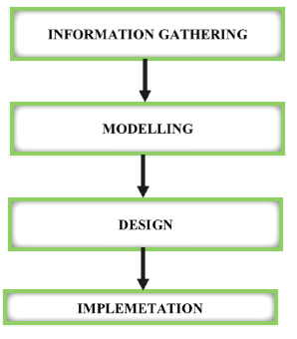

**Fig-3.1 Methodology Plan**

**3.2 System Design**

It is the most creative and challenging phase of the system life cycle. The analysis phase is used to design the logical model of the system whereas the design phase is used to design the physical model. Many things are to be done in this phase .we began the designing process by identifying forms, reports and the other outputs the system will produce. Then the specify data on each were pinpointed. we sketched the forms or say, the displays, as expected to appear, on paper, so it serves as model for the project to began finally we design the form on computer display, using one of the automated system design tool, that is PHP 7.0.

 After the forms were designed, the next step was to specify the data to be inputted, calculated and stored individual data items and calculation procedure were written in detail. File structure such as paper files were selected the procedures were written so as how to process the data and procedures the output during the programming phase. The documents were design ion the form of charts. Output design means what should be the format for presenting the results. It should be in most convenient and attractive format for the user. The input design deals with what should be the input to the system and thus prepare the input format. File design deals with how the data has to be stored on physical devices. Process design includes the description of the procedure for carrying out operations on the given data.

**3.3 Design Decisions**

The system design process is a step-by- step adherence of clear procedures and guidelines. Though, certain clear procedures and guidelines have emerged in recent days. But still much of design work depends on knowledge and experience of the designer. When designer works working in system design, he will face different type of problems. Many of these will be due to constraints imposed by the user or limitations of the hardware and software available in the market. Sometimes it is difficult to enumerate the complexity of the problems and solutions there of since the variety of likely problems is so great and no solutions are exactly similar. However, following considerations should be kept in mind during the system designing phase:-design objectives, practicality, efficiency, cost etc. Major designs are:-

**3.3.1 Database Design:** This activity deals with the design of the physical database. Program design: In conjunction with database design is a decision on the programming language to be used and the flowcharting and coding, and debugging procedure prior to conversion. The operating system limits the programming languages that will run of the system.

System and program test preparation-Each aspect of the system has a separate test requirements. System testing is done after all programming and testing completed the test on the system and program test requirements become a part of design  specifications a prerequisite to implementation.

**3.3.2 Design Process:** The computer system design process is an exercise of specifying how, the system will work. It is an iterative process, which is based on the system will be do as shown in the feasibility report. Mainly, following five parts have been included in the system design process.

**3.3.3 Output Design:** The starting point of the design process is the proper knowledge of system requirements which will normally be converted in terms of output.

**3.3.4 Input Design:** Once the output requirements have been finalized, the next step is to find out what data need to be made available to the system to produce the desired outputs. The basic documents in which these data are available need to be identified. If necessary, these documents may have to be revised or new documents may have to be introduced.

**3.3.5 File Design:** Once the input data is captured in the system, these may to be preserved either for a short or long period. These data will generally be stored in files in a logical manner. The designer will have to devise the techniques of storing and retrieving data from these files.

**3.3.7 Procedure Design:** This step involves specifications of how processing will be performed. In this, there are two aspects:

**3.3.6 Computer Procedure:** The computer procedure will specify what functions will be carried out on computer, what will be different programs and in what sequence the program will be run.

**3.3.7 Non-computer Procedure:** The non-computer procedure will specify the manual procedures for feeding input data, receiving outputs etc.

**3.4 Design Technique**

Design is a multi-steps process that focuses on data structure, software, software architecture, external details and interface between the modules. The design processes also translate the requirements into representation of software that can be accessed for quality before coding begins. Computer software designs changes continually as new methods, better analysis and broader understanding evolve. Software design is at a relatively early stage in its revolution. Therefore, software design methodology locks the depth, flexibility and quantitative nature that are normally associated with more classical engineering disciplines.

However techniques for software design do exist, criteria for design qualities are available and design notation can be applied.  Once software requirements have been analyzed and specified, software design is the first of three activities- Design, code, test, that are required to build and verify software. Each activities transform information in a manner that ultimately results in a validation of computer software. The importance software design can be started with a single word quality. Design is the place where quality fostered in software development. Design provides us with the representations of the software that can be accessed for quality. Design the only way that we can accurately translate a customer’s requirement into a finished software product or system. Without design, risk of building an unstable system exists-one that will fail when small changes are made one that may be difficult to test.

**3.4.1   Internal Design**

The input design is the link between the information system and the users. It comprises the directing specification and procedures for data preparations and those steps that are necessary to put transaction data into a usable form for processing data entry. The designs of inputs focuses on controlling the amount of inputs required, controlling errors, avoiding delay, avoiding extra steps and keeping the process simple.  System analyst decides the following input designs details:

* Why data to input?
* What medium to use?
* How the data should be arranged or coded?
* The dialogue to guide users in providing input.
* Methods for performing input validation and steps to follow when error occurs.

Several activities have to be carried out as part of the overall input process. They include some or all of the following stages

* Data recording (that is, collection of data at its source);
* Data transcription (that is, transfer of data to an input form);
* Data conversion (that is, checking the conversion);
* Data control (that is, checking the accuracy and controlling the flow of  the data to the computer);
* Data transmission (that is, transmitting or transporting the data to the computer);
* Data validation (that is, checking the input data by program when it  enters the computer system);
* Data correction (that is, correcting the errors that are found at any of the earlier stages).

**3.4.2   External Design**

Designing computer output should proceed in an organized, well thought out manner. The term output applies to any information produced by an information system whether printed or displayed. When analyst designs computer output, they identified the specific output is needed to meet the information requirements. Computer output is the most important and direct source of information to the user. Output design is a process that involves designing necessary outputs that have to be various users according to their requirements.

Efficient intelligent output design should improve the systems relationship with the users and help in decision-making.  Since the reports are directly required by the management for taking decisions and to draw conclusions, they must be designed with utmost care and the details in the records must be simple, descriptive and clear to the user. The options for the outputs and reports are given in the systems menu. When designing output, system analyst must accomplish the following:

* Determine the information to present.
* Decide whether to display or print the information and select the output medium.
* Arrange the present of information acceptable format.
* Decide how to distribute the output to intended receipts.

**3.4.3   Architectural Design**

Architectural design begins with recognition that the screen is composed of different areas. Layout tools assist the analyst in specifying the content of the single and multiple design formats. All screens have been provided with menus, push buttons facilities, icons and control buttons such as add/delete/edit/find/clear /exit etc. The main screen consists of main menu from which we can move to another forms or screens.  In designing output screens we need area for:

* Heading and titles.
* The content of display.
* Message and instruction.
* Sometimes explanations for information in the reports

**3.4.4   Procedural Design**

The procedural design transforms structural component in to a procedural description of the software. Source is generated and testing is conducted to integrate and validate to software. The design of input and output screen comes under the procedural design input/output design is according to needs of the user. The input and output design are related to each other in sense that the accuracy data depends on the accuracy of the input data and processing of input data. Thus for this proposed system the input and output design are in the form of forms. In the forms based interface design the user give the input by filling the blanks of the screen.

**3.4.5 Database Design**

Database files are the key source of information into the system. It is the process of designing database files which are the key source of information to the system. The files should be properly designed and planned for collection, accumulation, editing the required information. The objectives of the file design are to provide effective auxiliary storage and to contribute to the overall the efficiency of the computer program component of the system. In concepts of database design, there are two types of data – physical data and logical data.

Physical data is that which is written on those pieces of paper. Logical data are those, which are calculated based on some of the retrieved data in a certain sequence in summary form. In a computer-based data processing system, separation of physical and logical data provides the same advantages.

**Database: Ecom**

**Table structure for table `admin`**

CREATE TABLE `admin` (

  `id` int(11) NOT NULL,

  `username` varchar(255) NOT NULL,

  `password` varchar(255) NOT NULL,

  `creationDate` timestamp NOT NULL DEFAULT current_timestamp(),

  `updationDate` varchar(255) NOT NULL)

**Table structure for table `category`**

CREATE TABLE `category` (

  `id` int(11) NOT NULL,

  `categoryName` varchar(255) DEFAULT NULL,

  `categoryDescription` longtext DEFAULT NULL,

  `creationDate` timestamp NOT NULL DEFAULT current_timestamp(),

  `updationDate` varchar(255) DEFAULT NULL)

**Table structure for table `orders`**

CREATE TABLE `orders` (

  `id` int(11) NOT NULL,

  `userId` int(11) DEFAULT NULL,

  `productId` varchar(255) DEFAULT NULL,

  `quantity` int(11) DEFAULT NULL,

  `orderDate` timestamp NOT NULL DEFAULT current_timestamp(),

  `paymentMethod` varchar(50) DEFAULT NULL,

  `orderStatus` varchar(55) DEFAULT NULL)

**Table structure for table `ordertrackhistory`**

CREATE TABLE `ordertrackhistory` (

  `id` int(11) NOT NULL,

  `orderId` int(11) DEFAULT NULL,

  `status` varchar(255) DEFAULT NULL,

  `remark` mediumtext DEFAULT NULL,

  `postingDate` timestamp NOT NULL DEFAULT current_timestamp())

**Table structure for table `productreviews`**

CREATE TABLE `productreviews` (

  `id` int(11) NOT NULL,

  `productId` int(11) DEFAULT NULL,

  `quality` int(11) DEFAULT NULL,

  `price` int(11) DEFAULT NULL,

  `value` int(11) DEFAULT NULL,

  `name` varchar(255) DEFAULT NULL,

  `summary` varchar(255) DEFAULT NULL,

  `review` longtext DEFAULT NULL,

  `reviewDate` timestamp NOT NULL DEFAULT current_timestamp())

**Table structure for table `products`**

CREATE TABLE `products` (

  `id` int(11) NOT NULL,

  `category` int(11) NOT NULL,

  `subCategory` int(11) DEFAULT NULL,

  `productName` varchar(255) DEFAULT NULL,

  `productCompany` varchar(255) DEFAULT NULL,

  `productPrice` int(11) DEFAULT NULL,

  `productPriceBeforeDiscount` int(11) DEFAULT NULL,

  `productDescription` longtext DEFAULT NULL,

  `productImage1` varchar(255) DEFAULT NULL,

  `productImage2` varchar(255) DEFAULT NULL,

  `productImage3` varchar(255) DEFAULT NULL,

  `shippingCharge` int(11) DEFAULT NULL,

  `productAvailability` varchar(255) DEFAULT NULL,

  `postingDate` timestamp NULL DEFAULT current_timestamp(),

  `updationDate` varchar(255) DEFAULT NULL)

**Table structure for table `users`**

CREATE TABLE `users` (

  `id` int(11) NOT NULL,

  `name` varchar(255) DEFAULT NULL,

  `email` varchar(255) DEFAULT NULL,

  `contactno` bigint(11) DEFAULT NULL,

  `password` varchar(255) DEFAULT NULL,

  `shippingAddress` longtext DEFAULT NULL,

  `shippingState` varchar(255) DEFAULT NULL,

  `shippingCity` varchar(255) DEFAULT NULL,

  `shippingPincode` int(11) DEFAULT NULL,

  `billingAddress` longtext DEFAULT NULL,

  `billingState` varchar(255) DEFAULT NULL,

  `billingCity` varchar(255) DEFAULT NULL,

  `billingPincode` int(11) DEFAULT NULL,

  `regDate` timestamp NOT NULL DEFAULT current_timestamp(),

  `updationDate` varchar(255) DEFAULT NULL)

**Table structure for table `**wishlist **`**

CREATE TABLE `wishlist` (

  `id` int(11) NOT NULL,

  `userId` int(11) DEFAULT NULL,

  `productId` int(11) DEFAULT NULL,

  `postingDate` timestamp NOT NULL DEFAULT current_timestamp())

**Chapter - 4**

**Data Flow Diagram and E-R Diagram**

**4.  Data Flow Diagrams**

A data flow diagram is graphical tool used to describe and analyse movement of data through a system.  These are the central tool and the basis from which the other components are developed.  The transformation of data from input to output, through processed, may be described logically and independently of physical components associated with the system. These are known as the logical data flow diagrams.  The physical data flow diagrams show the actual implements and movement of data between people, departments and workstations.  A full description of a system actually consists of a set of data flow diagrams.  Process is further identified with a number that will be used for identification purpose.

The development of DFD’S is done in several levels.  Each process in lower level diagrams can be broken down into a more detailed DFD in the next level.  The lop-level diagram is often called context diagram. It consists single process bit, which plays vital role in studying the current system.  The process in the context level diagram is exploded into other process at the first level DFD.  The idea behind the explosion of a process into more process is that understanding at one level of detail is exploded into greater detail at the next level.  This is done until further explosion is necessary and an adequate amount of detail is described for analyst to understand the process.

**Rules for DFD**

* Fix the scope of the system by means of context diagrams.
* Organize the DFD so that the main sequence of the actions
* Reads left to right and top to bottom.
* Identify all inputs and outputs.
* Identify and label each process internal to the system with Rounded   circles.
* Do not indicate hardware and ignore control information.
* Make sure the names of the processes accurately convey everything the process is done.
* There must not be unnamed process.
* Indicate external sources and destinations of the data, with Squares.
* Number each occurrence of repeated external entities.
* Identify all data flows for each process step, except simple Record retrievals.
* Label data flow on each arrow.
* Use details flow on each arrow.
* Use the details flow arrow to indicate data movements.

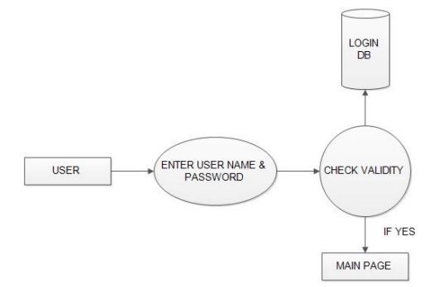

**Fig 4.1: Login DFD**

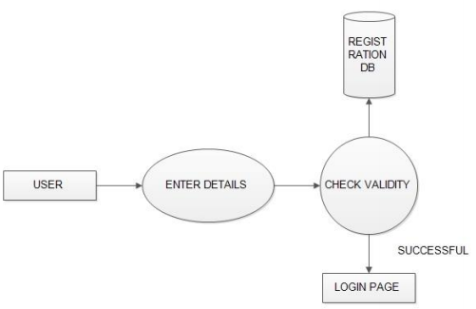

**Fig 4.2: Registration DFD**

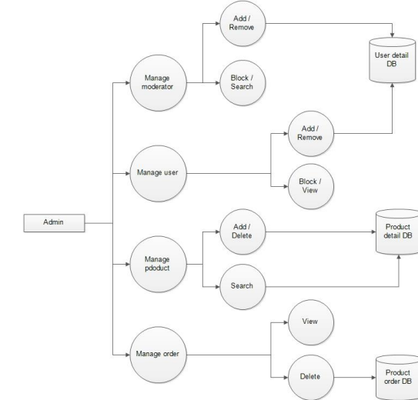

**Fig 4. 3: Admin DFD**

**4.1 E-R Diagrams**

The Entity-Relationship (ER) model was originally proposed as a way to unify the network and relational database views. Simply stated the ER model is a conceptual data model that views the real world as entities and relationships. A basic component of the model is the Entity-Relationship diagram which is used to visually represent data objects. The model has been extended and today it is commonly used for database design for the database designer, the utility of the ER model is:

* It maps well to the relational model. The constructs used in the ER model can easily be transformed into relational tables.
* It is simple and easy to understand with a minimum of training. Therefore, the model can be used by the database designer to communicate the design to the end user.
* In addition, the model can be used as a design plan by the database developer to implement a data model in a specific database management software.

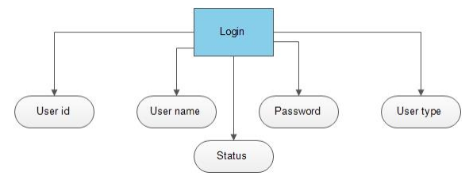

**Fig 4.1.1: Login**

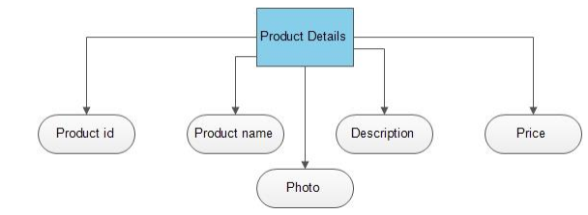

**Fig 4.1.2: Product Details**

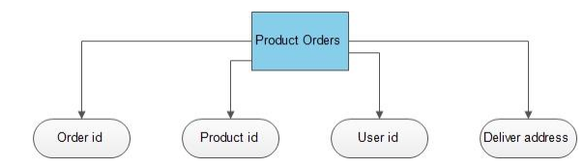

**Fig 4.1.3: Product Orders**

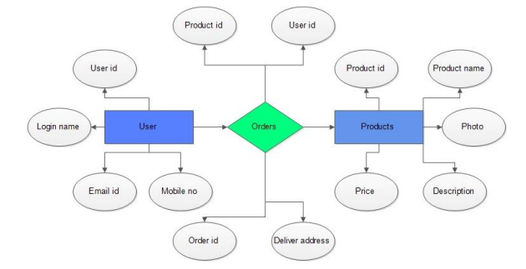

**Fig 4.1.4: Complete Diagram**

**4.2 Context Diagram**

The Context Diagram shows the system under consideration as a single high-level process and then shows the relationship that the system has with other external entities. Context Diagram is a Context-Level Data-Flow Diagram or a Level-0 Data Flow Diagram.  Since a Context Diagram is a specialized version of Data-Flow Diagram, understanding a bit about Data-Flow Diagrams can be helpful.

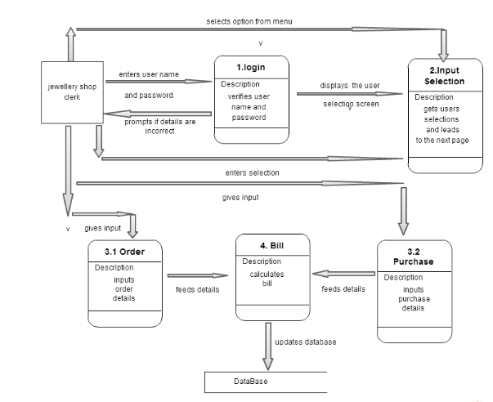

**4.3 Use Case Diagram**

A use case diagram is a dynamic or behavior diagram in UML. Use case diagrams model the functionality of a system using actors and use cases. Use cases are a set of actions, services, and functions that the system needs to perform.

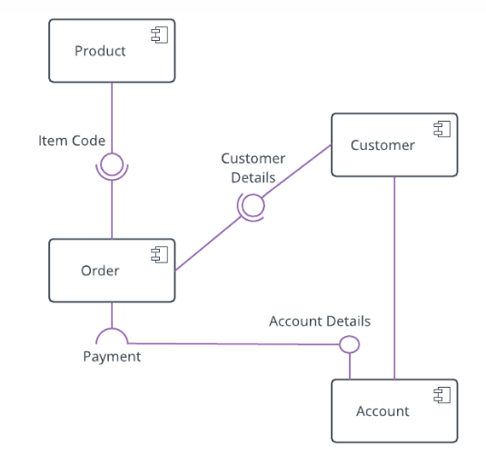

**4.4 Sequacial Diagram**

A sequence diagram simply depicts interaction between objects in a sequential order i.e. the order in which these interactions take place. We can also use the terms event diagrams or event scenarios to refer to a sequence diagram. Sequence diagrams describe how and in what order the objects in a system function.

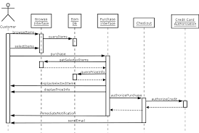

**4.5 Activity Diagram**

The activity diagram used to describe flow of activity through a series of actions. Activity diagram is a important diagram to describe the system. The activity described as a action or operation of the system.

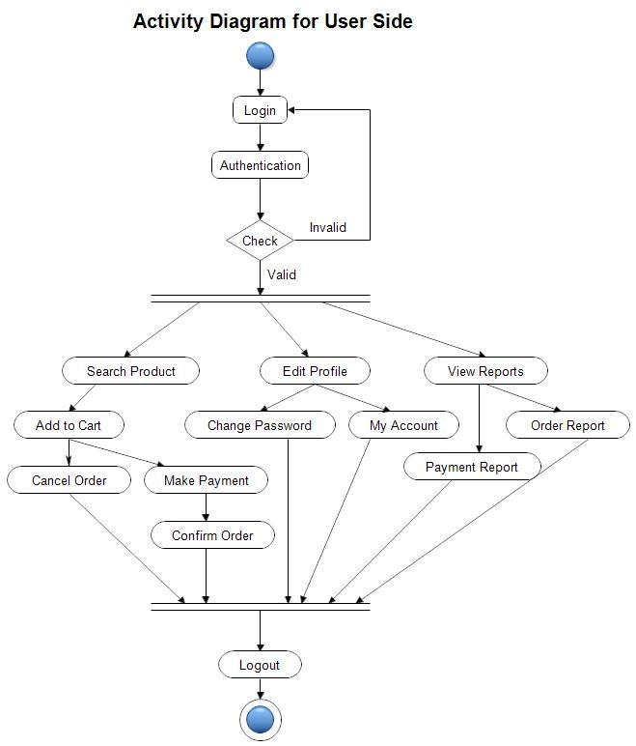

**Chapter- 5**

**Testing Analysis and Evaluation**

**5.** **Overview**

Software testing is defined as an activity to check whether the actual results match the expected results and to ensure that the software system is Defect free. It involves execution of a software component or system component to evaluate one or more properties of interest. Software testing also helps to identify errors, gaps or missing requirements in contrary to the actual requirements. It can be either done manually or using automated tools.

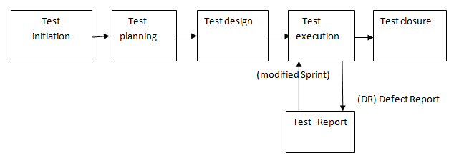

Test Analysis is the process of looking into test artifacts to base your test conditions/test cases. Hence, it is also called Test Basis. Testers can create Test Conditions by looking into the Application under Test or use their experience. But mostly, test cases are derived from test artifacts. Testing is a set of activities that can be planned in advanced and conducted systematically. A strategy for software testing must accommodation low-level tests that are necessary to verify that a small source code segment has been correctly implemented as well as high-level tests that validate major system functions against customer requirements.

**Software Testing Life Cycle**

The Software Development Life Cycle (SDLC) likewise testers also follow the Software Testing Life Cycle which is called as STLC. It is the sequence of activities carried out by the testing team from the beginning of the project till the end of the project. Software Testing Life Cycle is a testing process which is executed in a sequence, in order to meet the quality goals. It is not a single activity but it consists of many different activities which are executed to achieve a good quality product. There are different phases in STLC which are given below:

* Requirement analysis
* Test Planning
* Test case development
* Environment Setup
* Test Execution
* Test Cycle Closure

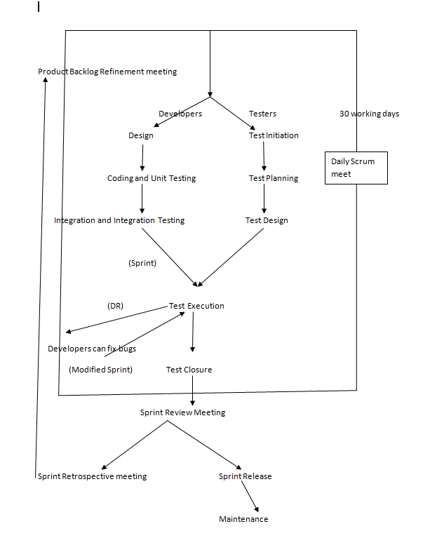

**Fig 5.1 Software Development Life Cycle**

**5.1 The Principles of Testing**

**1) Testing shows presence of defects:** Testing can show the defects are present, but cannot prove that there are no defects. Even after testing the application or product thoroughly we cannot say that the product is 100% defect free. Testing always reduces the number of undiscovered defects remaining in the software but even if no defects are found, it is not a proof of correctness.

**2) Exhaustive testing is impossible:** Testing everything including all combinations of inputs and preconditions is not possible. So, instead of doing the exhaustive testing we can use risks and priorities to focus testing efforts. For example: In an application in one screen there are 15 input fields, each having 5 possible values, then to test all the valid combinations you would need 30  517  578  125  (515) tests. This is very unlikely that the project timescales would allow for this number of tests. So, accessing and managing risk is one of the most important activities and reason for testing in any project.

**5.1.1 Unit Testing**

Unit testing focuses verification efforts on the smallest unit of software design module. The unit test is always white box oriented. The tests that occur as part of unit testing are testing the module interface, examining the local data structures, testing the boundary conditions, execution all the independent paths and testing error-handling paths. Using the details design description as a guide, important control paths are tested to uncover errors within boundary of the boundary of the module. The relative complexity of tests and the errors detected as a result is limited by the constrained scope established for unit testing. Unit testing is normally considered an adjacent to coding steps. After source level code has been developed, reviewed, and verified for correct syntax, unit test case design begins. A review of design information provides guidance for establishing test cases that are likely to uncover error in each case of the categories discussed above. Each test case should be coupled with a set of expected results.

**5.1.2 Integration Testing**

Integration testing is a systematic technique or construction the program structure while at the same time conducting tests to uncover errors associated with interfacing. Scope of testing summarizes the specific functional, performance, and internal design characteristics that are to be tested. It employs top-down testing and bottom-up testing methods for this case. The objective is to take unit tested modules and build a program structure that has been dictated by design. There is often a tendency to attempt no incremental integration; that is to construct the program using a “big bang “approach. The entire modules are combined in advance. The entire program is tested as whole and chaoses usually result! A set of error is encountered. Correction is difficult because the isolation of cause is complicated by the vast expanse of entire program. Once errors are corrected, new ones appear and process continues in a seemingly endless loop.

**5.1.3 Performance Testing**

Performance testing is the process of determining the speed, responsiveness and stability of a computer, network, software program or device under a workload. Performance testing can involve quantitative tests done in a lab, or occur in the production environment in limited scenarios. Different testing techniques require a different set of skill by testers. While performing Black box testing, the tester does not require the knowledge of coding. A good knowledge of JavaScript and SQL commands comes handy to avert such software security threats. Timing for both read and update transactions should be gathered to determine whether system functions are being performed in an acceptable timeframe.

**5.1.4 System Testing**

Quality assurance is an important step in software engineering. This overlaps with all the phases of development right from the requirement analysis. This quality requirement of the software system must be clearly extracted during the requirement analysis and all the subsequent phases should be made biased to that, the final testing will become trivial and less expensive. There are number of quality parameters like correctness, accuracy, reliability, robustness, efficiency, effectiveness, reusability, maintainability etc.. The state of requirement of each of these parameters will vary depending upon the name and domain of the application. The testing should be done at the end of all development steps.  Even though the final testing and verification are inevitable for better life and functionality of the software. The different software testing approaches and methods like white box testing and black box testing. The major phases in testing are design of test plan, setting up test case and test candidate and test procedure, testing and correction. This is a cycle process and the software will circulate through all the steps till it attends the required quality. The testing is carried in the following steps.

**5.1.5 Boundary Conditions Test**

Boundary value analysis is a type of black box or specification based testing technique in which tests are performed using the boundary values.  Boundary conditions as in case of generating sequences were tested to ensure that the module operates properly at boundaries establish to limit or restrict processing.

**5.1.6   Acceptance Testing**

Acceptance testing, a testing technique performed to determine whether or not the software system has met the requirement specifications. The main purpose of this test is to evaluate the system's compliance with the business requirements and verify if it is has met the required criteria for delivery to end users.

**5.1.7   Accessibility Testing**

Accessibility testing is a subset of usability testing where in the users under consideration people with all abilities and disabilities are. The significance of this testing is to verify both usability and accessibility.

**5.1.8   Integration Test**

The objective of Integration Test is to take the until tested modules and build a program structure that has been defined in the design.  We have done top down integration, which is constructing and testing small segments where errors are easier to isolate, and corrected.  The integration process was performed in three steps:

* The main control was used as test driver.
* Test was conducted as each module was integrated.
* Regret icon testing (conducting all or some of the previous tests) to ensure that new errors have not been introduced.

**5.1.9   Block Box Testing**

Black box testing, also known as Behavioral Testing, is a software testing method in which the internal structure/design/implementation of the item being tested is not known to the tester. These tests can be functional or non-functional, though usually functional. This method is named so because the software program, in the eyes of the tester, is like a black box; inside which one cannot see. This method attempts to find errors in the following categories:

* Incorrect or missing functions
* Interface errors
* Errors in data structures or external database access
* Behavior or performance errors
* Initialization and termination errors

**5.1.10 Validation Testing**

At the culmination of integration testing, software is completely assembled as a package, interfacing errors have been uncovered and corrected, and a final series of software tests namely validation tests are performed.  Validation succeeds when the software functions in the manner that can be easily accepted by the customer. After validation test has been conducted, one of the possible condition is satisfied. The functions or performance characteristics confirmed to specifications are acceptable. The deviation form specifications are uncovered and a note of what is lacking is made. The developed system has been tested satisfactorily and its performed is also satisfactory.  It is working efficiently.

**5.2 Test Environment Setup**

This phase includes the setup or installation process of software and hardware which is required for testing the application. In this phase the integration of the third party application is also carried out if required in the project. After setting up the required software and hardware the installation of build is tested. Once the installation of build is successful and complete then the Test Data is generated.

After the creation of Test data the Smoke testing is executed on the build in order to check whether the basic functionalities are working fine or not. This phase can be done in parallel with the Test Case Development phase. Activities to be done in Test Environment Setup phase are given below: As per the Requirement and Architecture document the list of required software and hardware is prepared

**5.3 Test Execution**

Before starting the Test Execution phase the Test Environment setup should be ready. In Test Execution phase the test cases are executed in the testing environment. While execution of the test cases the QA team may find bugs which will be reported against that test case. This bug is fixed by the developer and is retested by the QA.

**Chapter- 6**

**System Implementation and Maintenance**

**6. System Implementation**

Implementation is a process of ensuring that the information system is operational. Implementation allows the users to take over its operation for use and evaluation. It involves training the users to handle the system and plan for a smooth conversion.

**6.1 Training**

The personnel in the system must know in detail what their roles will be, how they can use the system, and what the system will or will not do. The success or failure of well-designed and technically elegant systems can depend on the way they are operated and used.

1. **Training Systems Operators**

Systems operators must be trained properly such that they can handle all possible operations, both routine and extraordinary. The operators should be trained in what common malfunctions may occur, how to recognize them, and what steps to take when they come. Training involves creating troubleshooting lists to identify possible problems and remedies for them, as well as the names and telephone numbers of individuals to contact when unexpected or unusual problems arise. Training also involves familiarization with run procedures, which involves working through the sequence of activities needed to use a new system

**6.1.2 User Training**

End-user training is an important part of the computer-based information system development, which must be provided to employees to enable them to do their own problem solving. User training involves how to operate the equipment, troubleshooting the system problem, determining whether a problem that arose is caused by the equipment or software. Most user training deals with the operation of the system itself. The training courses must be designed to help the user with fast mobilization for the organization.

**6.2 Maintenance**

To perform software maintenance effectively, various techniques are used. These include software configuration management, impact analysis, and software rejuvenation, all of which help in maintaining a system and thus, improve the quality of the existing system. Software maintenance is the process of modifying a software system or component after its delivery in order to correct faults, improve the performance and other attributes, or to adapt to the changed environment. Maintenance covers a wide range of activities including correcting the code and design errors, updating the documentation and test data, and upgrading the user support. There is an aging process that calls for periodic maintenance of hardware and software. Maintenance is always necessary to keep the system into its standards.

**6.2.1 Software Configuration Management**

Software configuration management can be used effectively while maintaining a system as it keeps track of changes and their effects on the system components. Many changes occur when the software is delivered to the users such as failure or users' request for enhancement in the software. For this, configuration control board (CCB) oversees the entire change process. Note that the representatives of CCB along with the users and developers manage changes collectively. These changes are managed in the following steps.

* When the user encounters a problem such as failure report, he requests for change on a formal change request form. The problem can also be an enhancement to a function, variation in the older function, or deleting an existing function.
* The procedure for request of change remains the same. The change request form should include information about how the system works, nature of the problem, and how the new (expected) system should work.
* If the user requests for a reported failure, the CCB discusses the source of the problem. If the requested change is an enhancement, the CCB discusses the parts or the components that will be affected by the change. In both the cases, developers describe the scope of changes and the expected time to implement them.
* The developers determine the source of the problem or the components which will be affected when the changes will be implemented. For this, they use a test copy instead of the operational system and implement the requested changes to see whether it (test copy) performs according to the requested changes.

**Chapter -7**

**Output Layout with Codes**

Index page: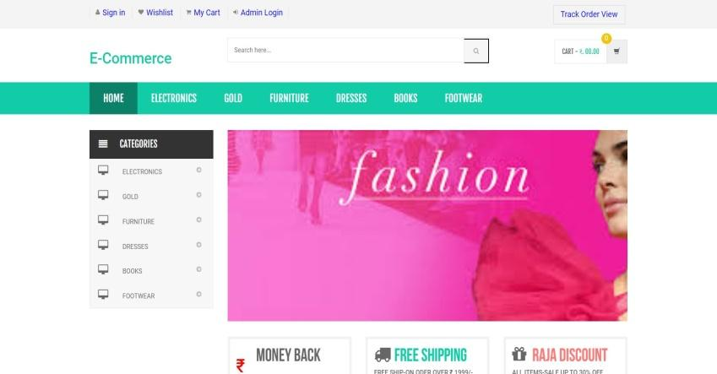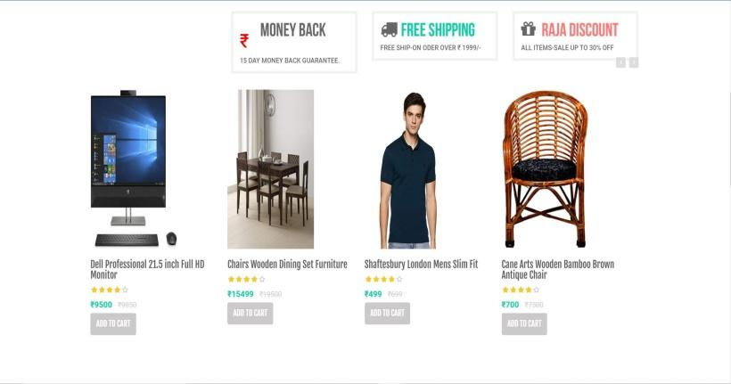

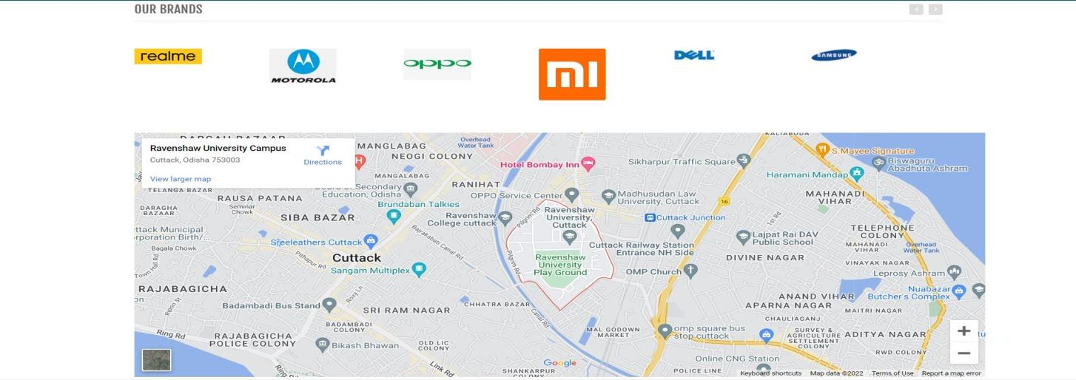  
  
  
  
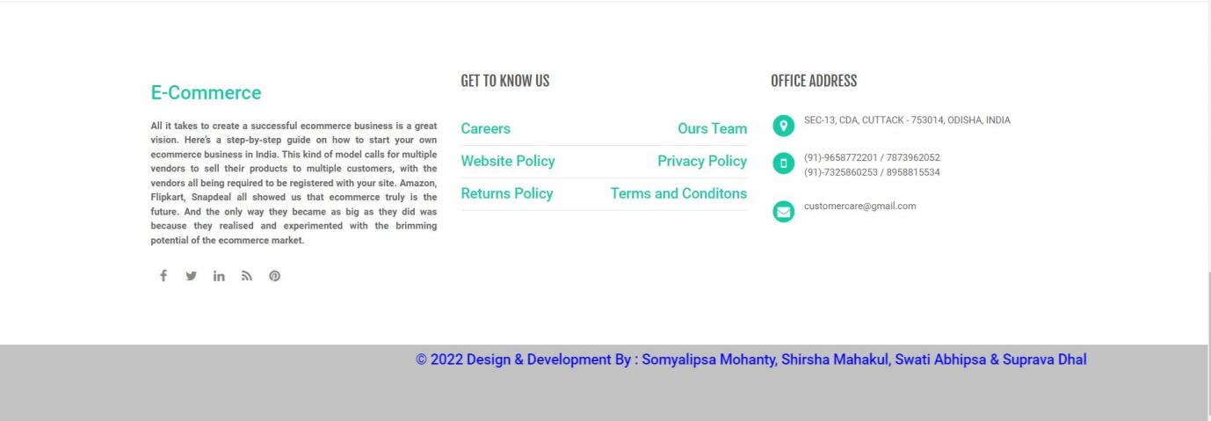

Sign in page:

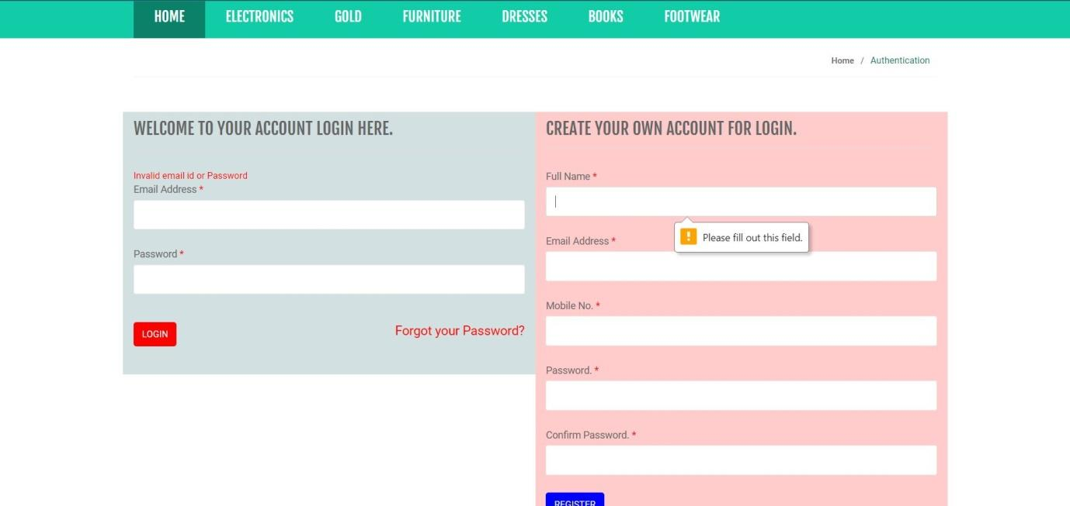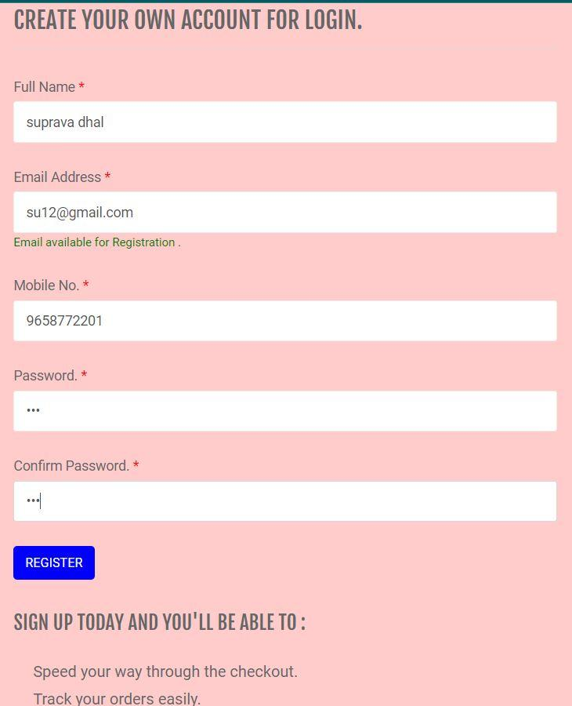

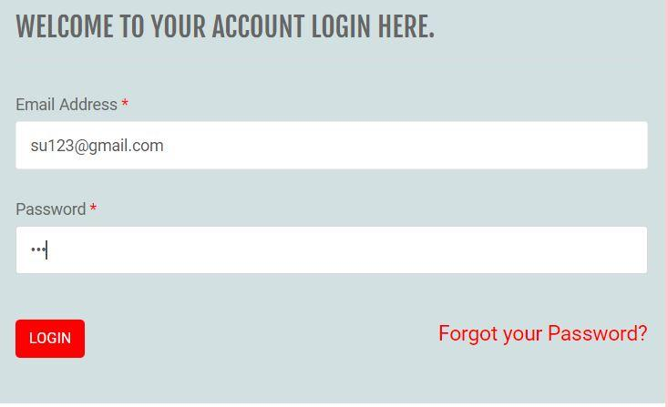

Forget password-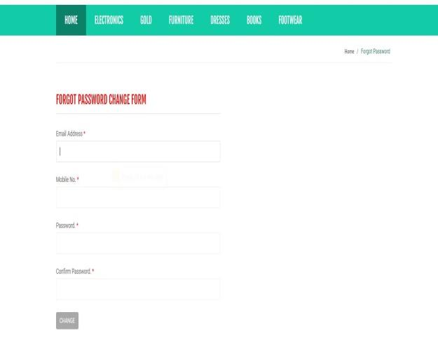

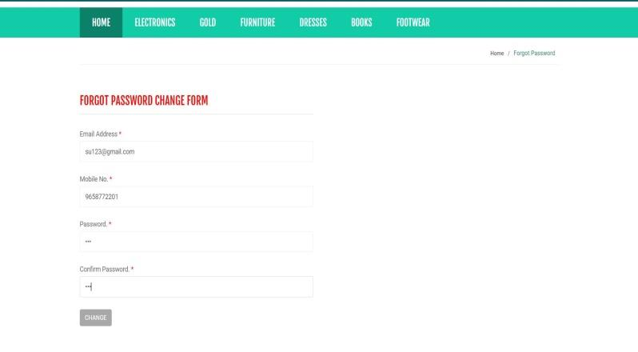

PRODUCTS:

ELECTRONICS-

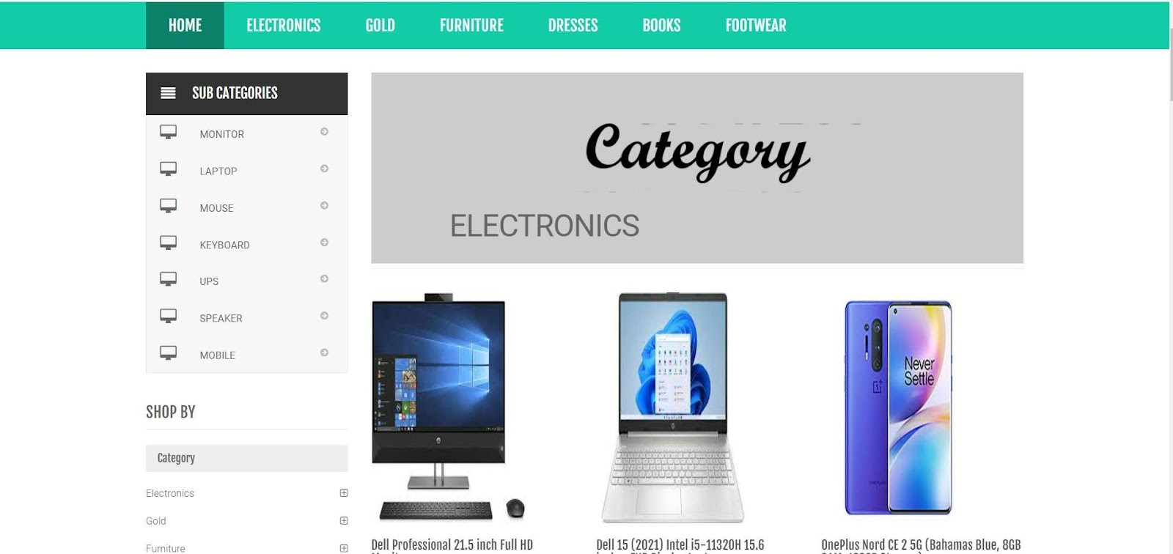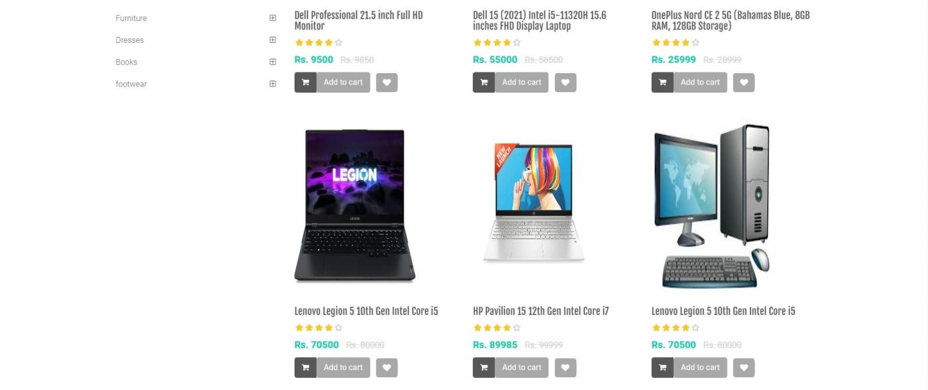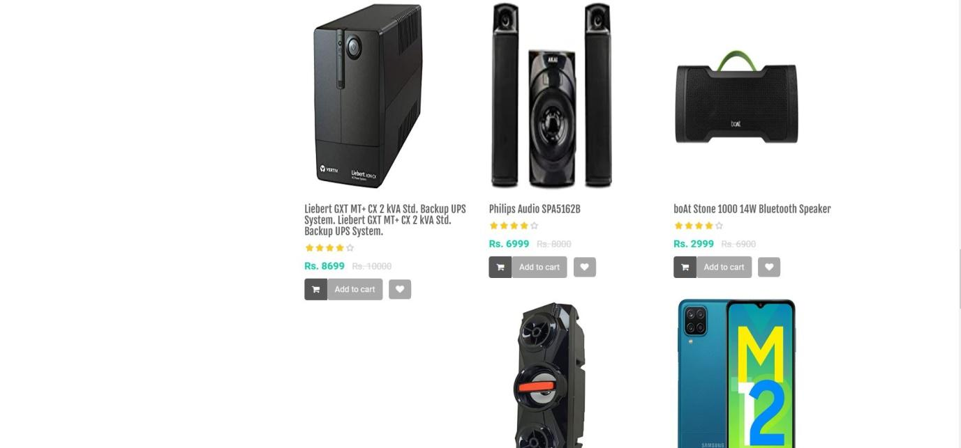

GOLD-

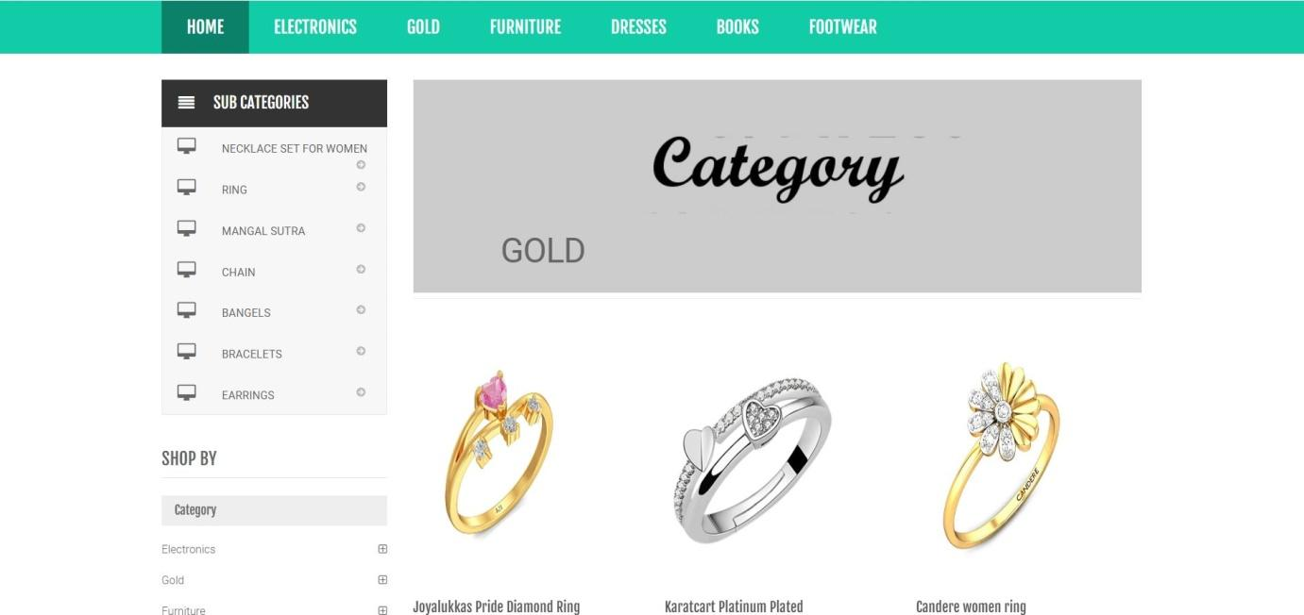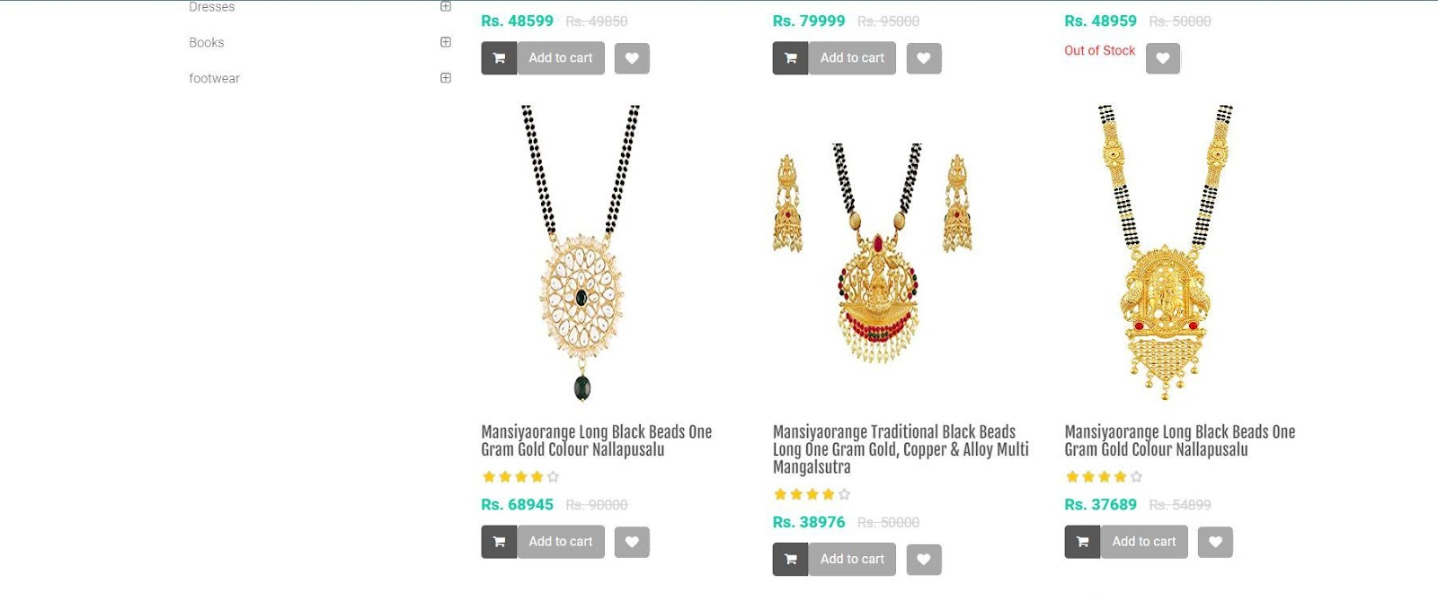

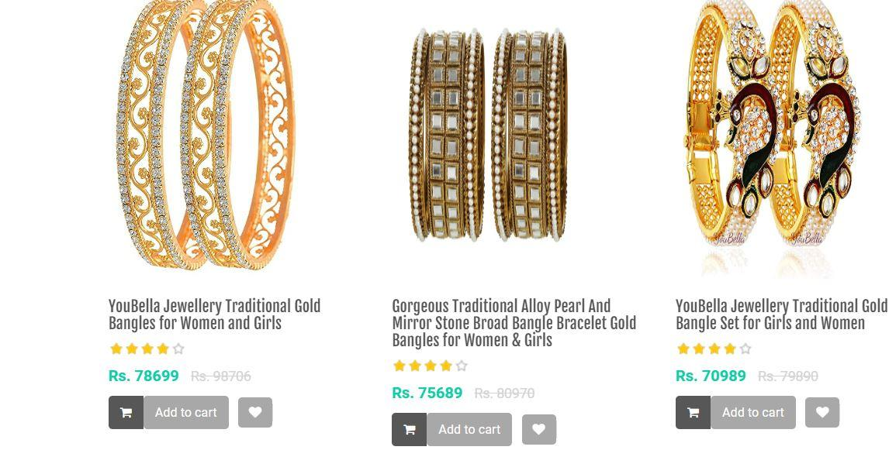

FURNITURE-

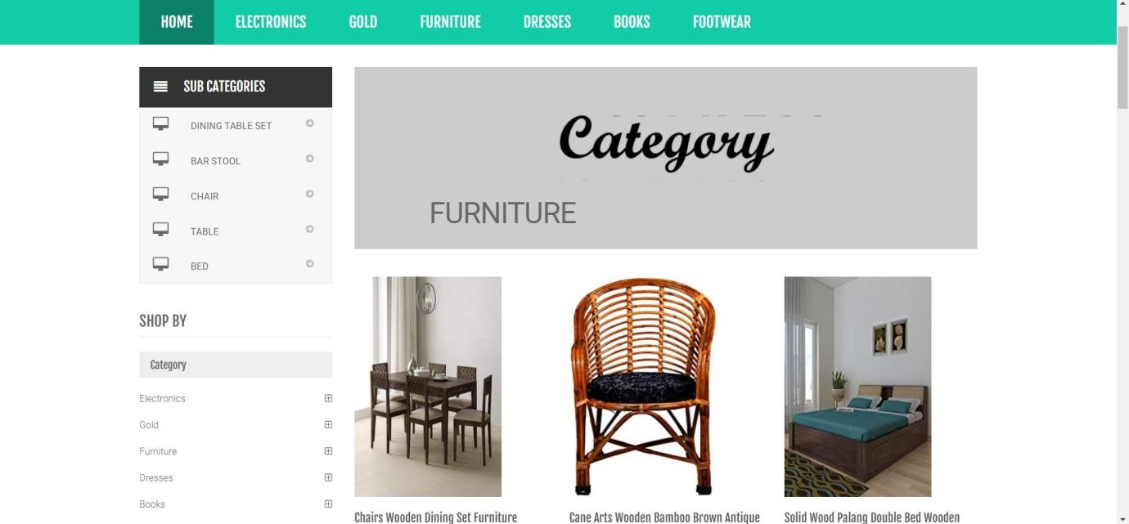

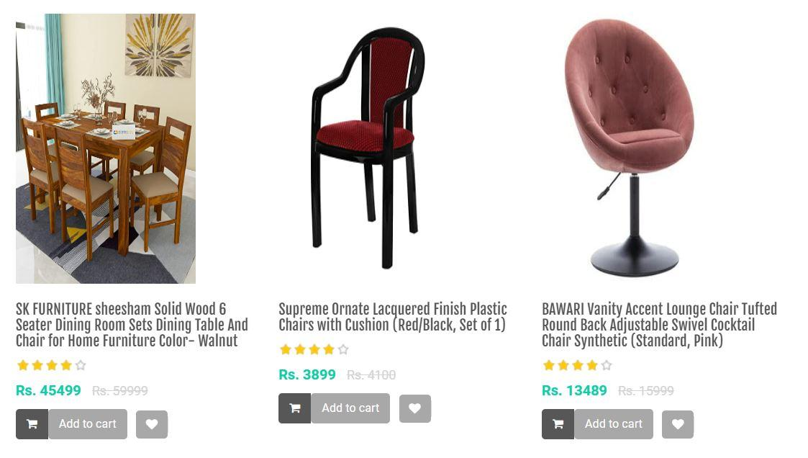

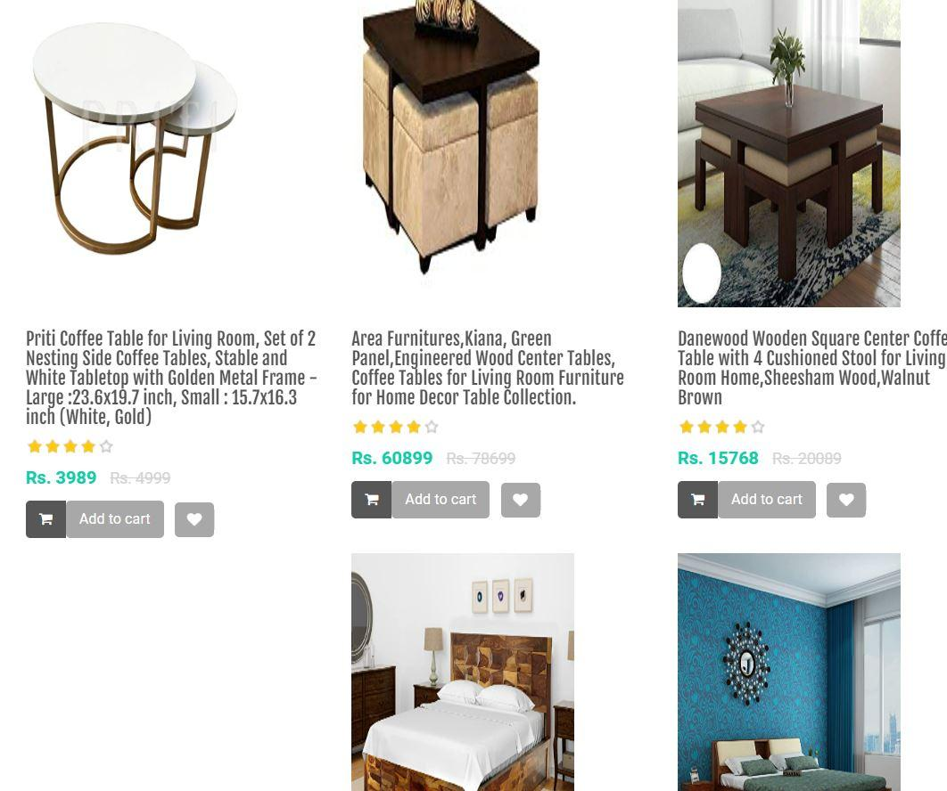

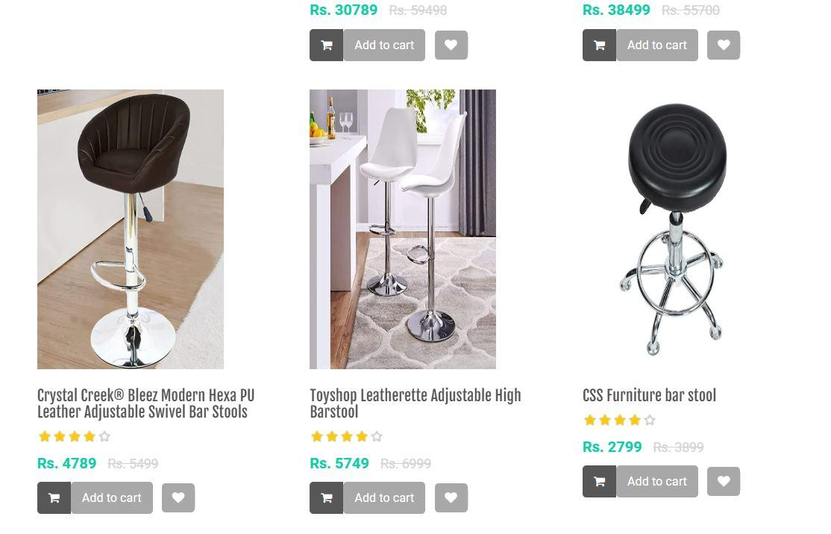

DRESS-

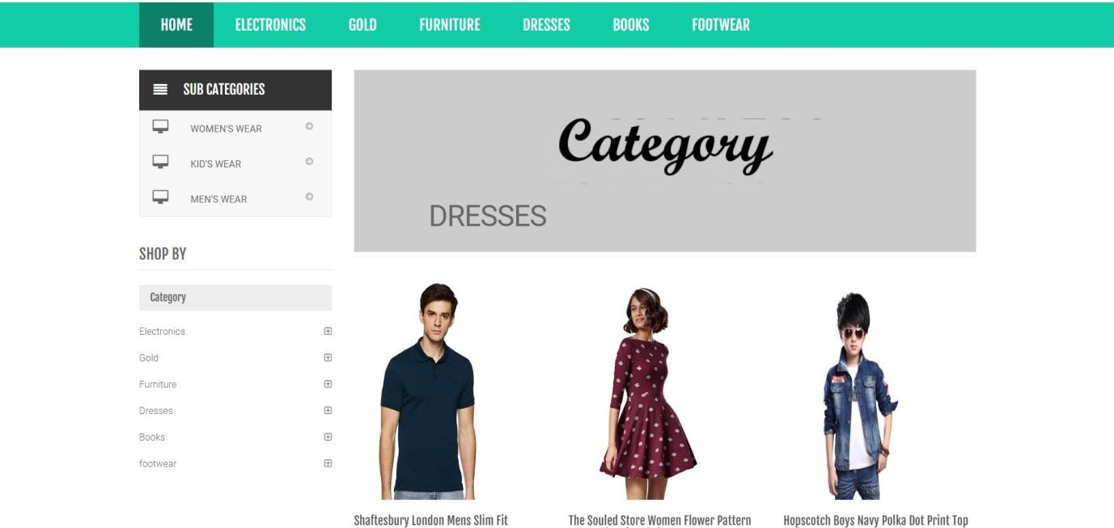

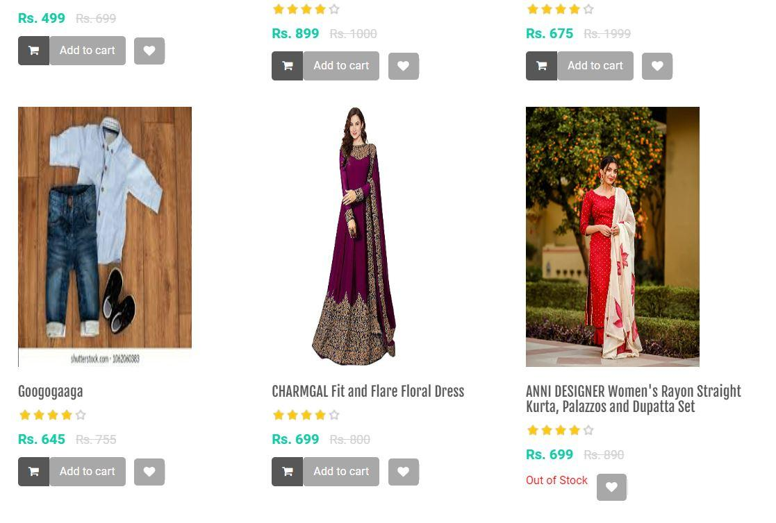

BOOKS-

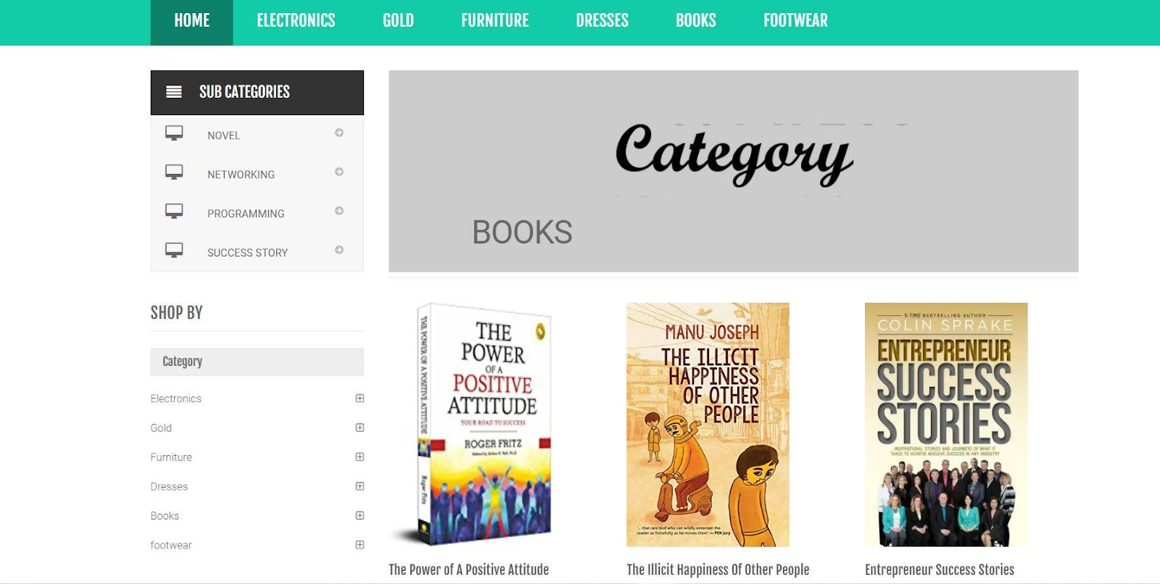

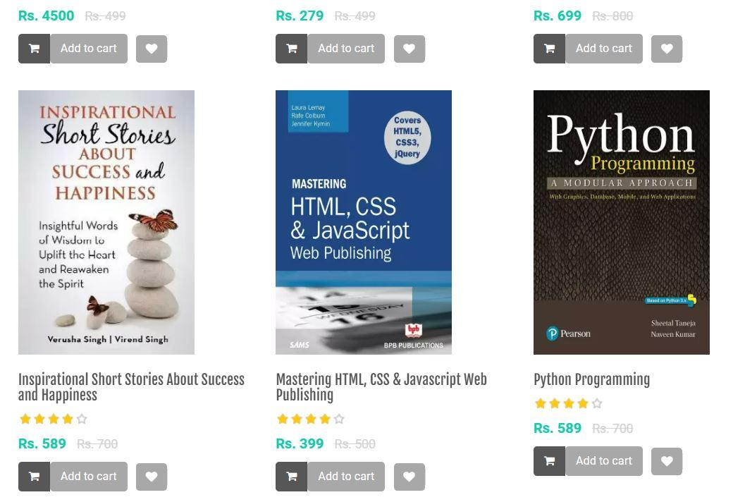

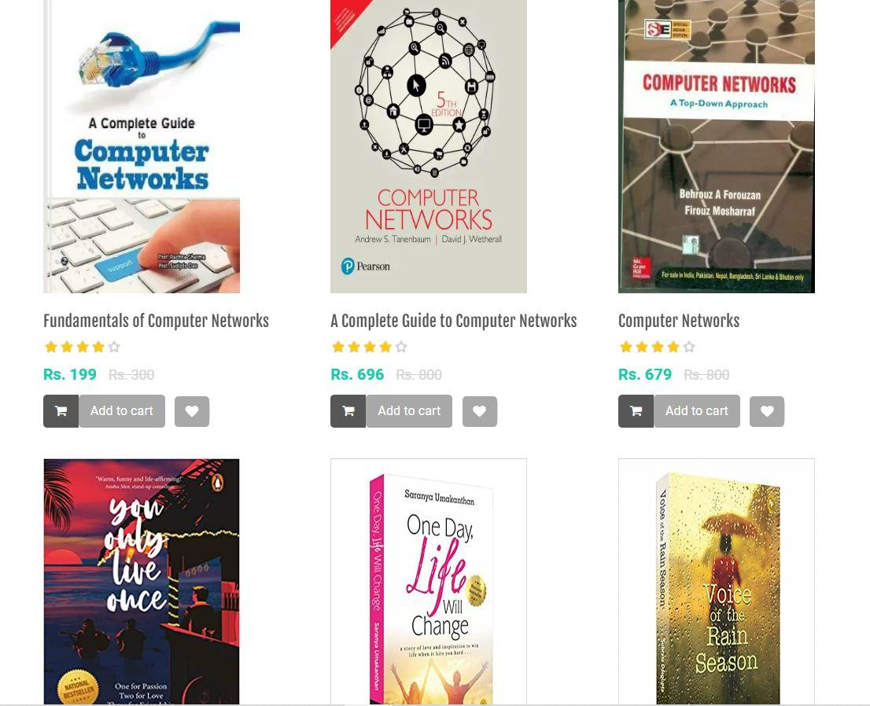

FOOTWEAR-

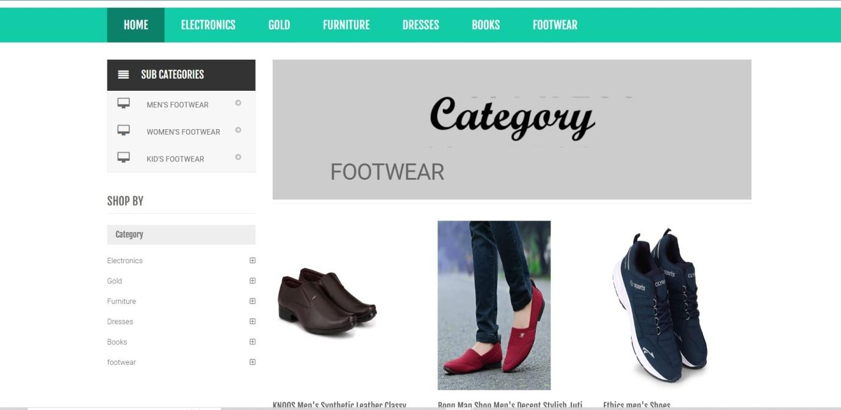

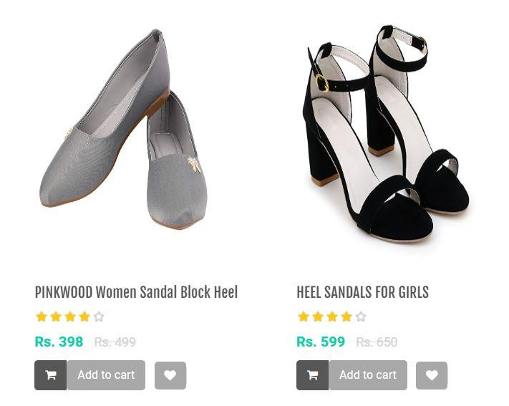

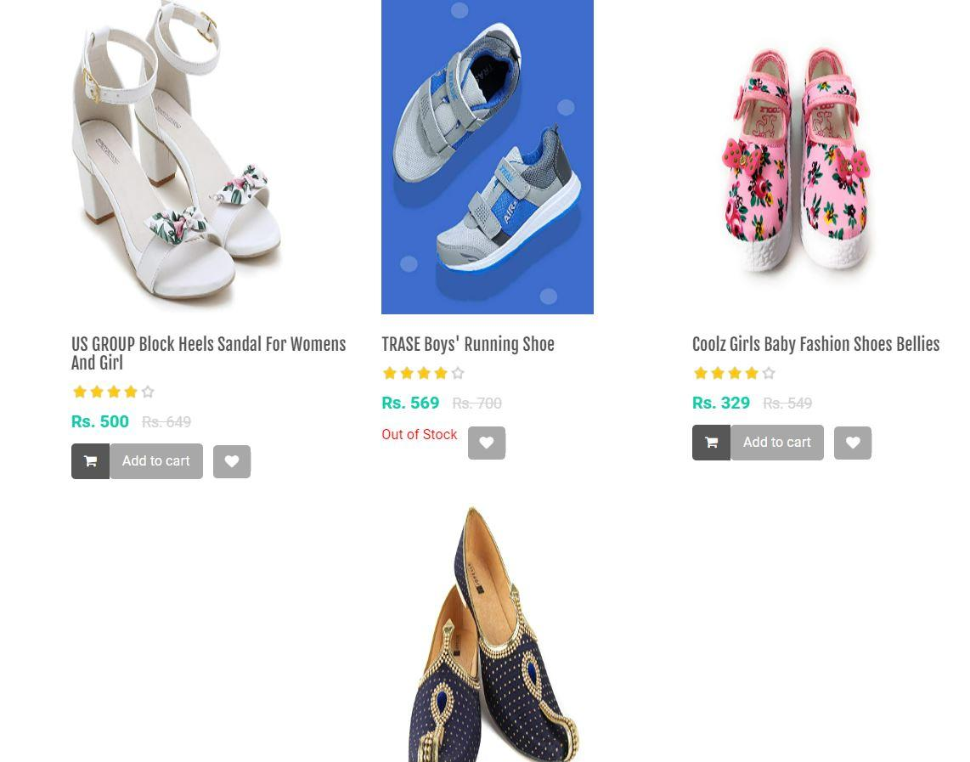

MY WISHLIST-

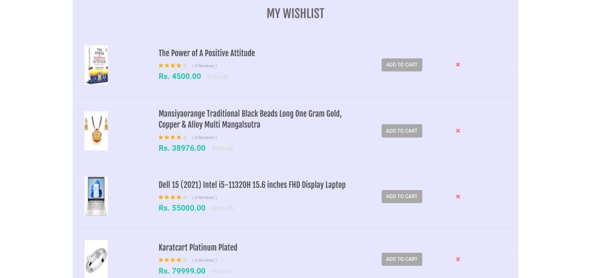

MY CART-

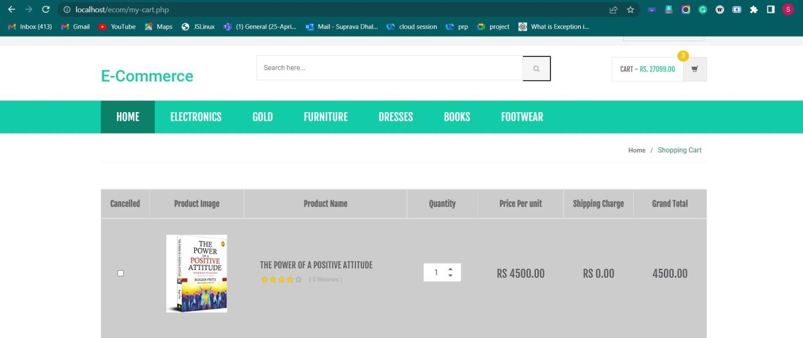

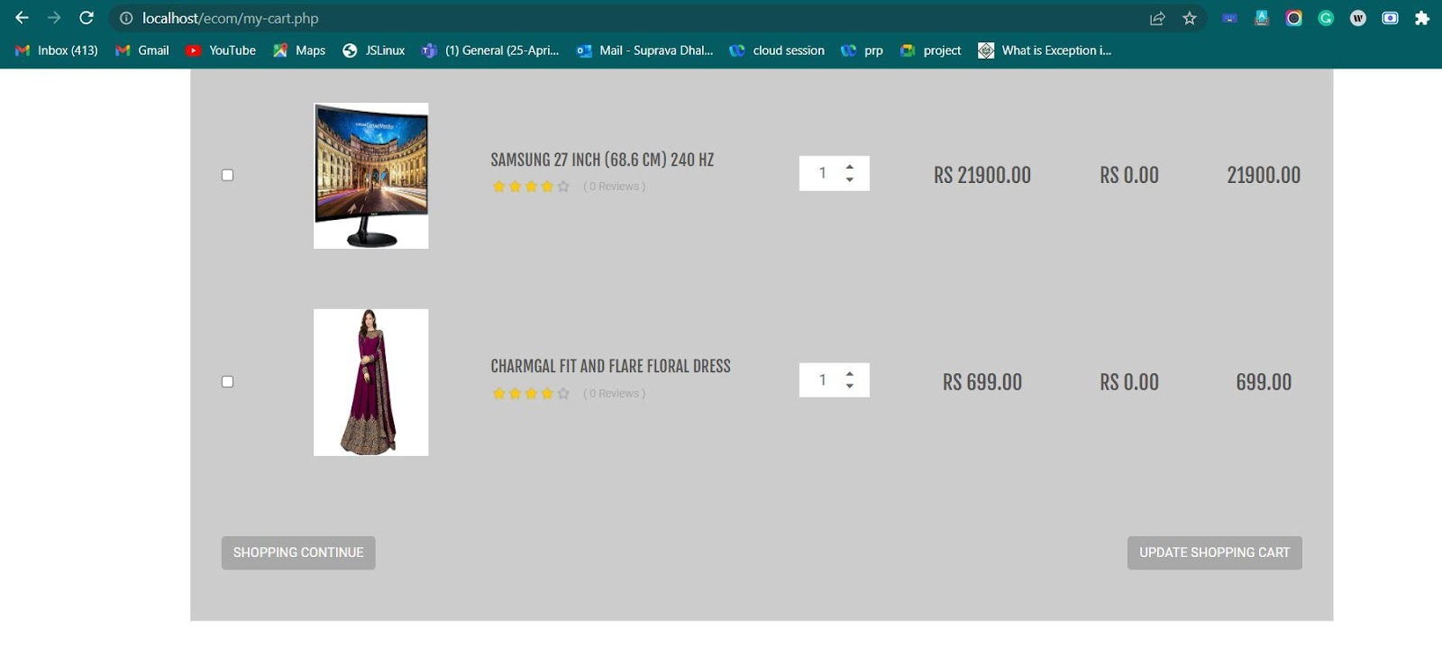

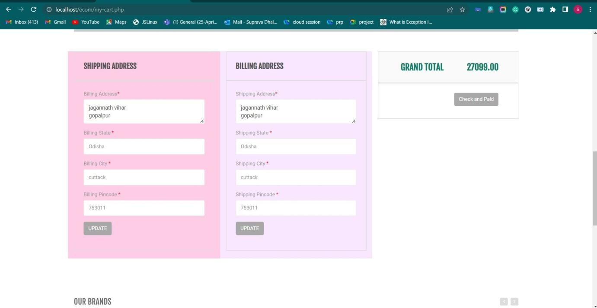

PAYMENT METHOD-

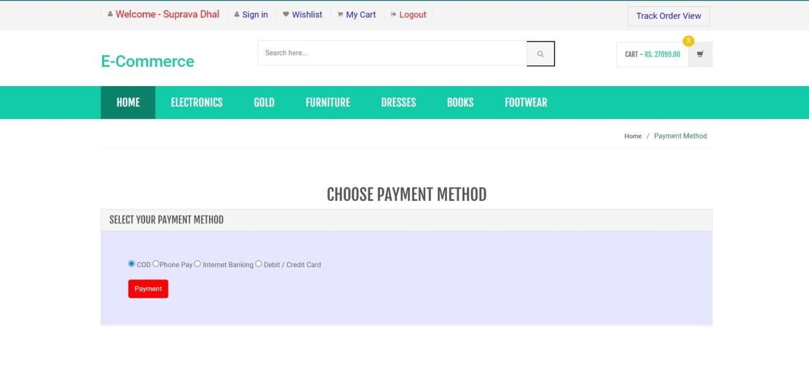

ORDER HISTORY-

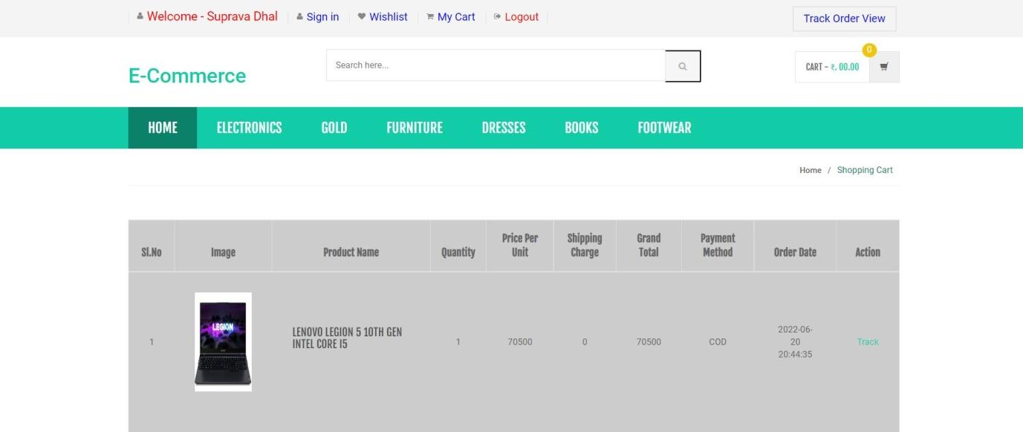

TRACK ORDER-

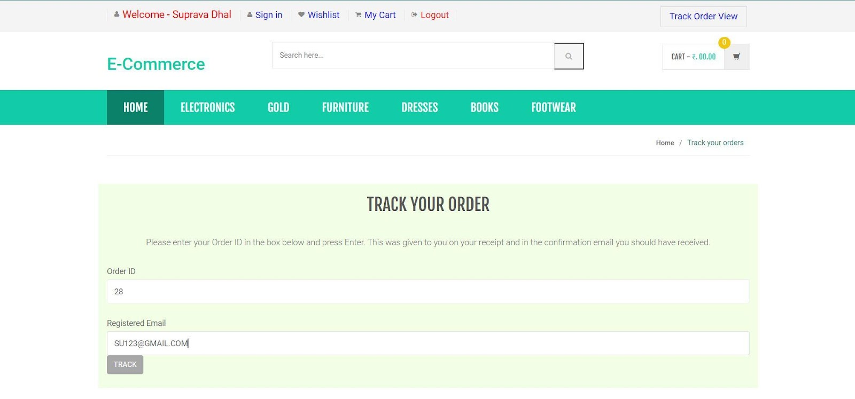

ORDER DETAILS-

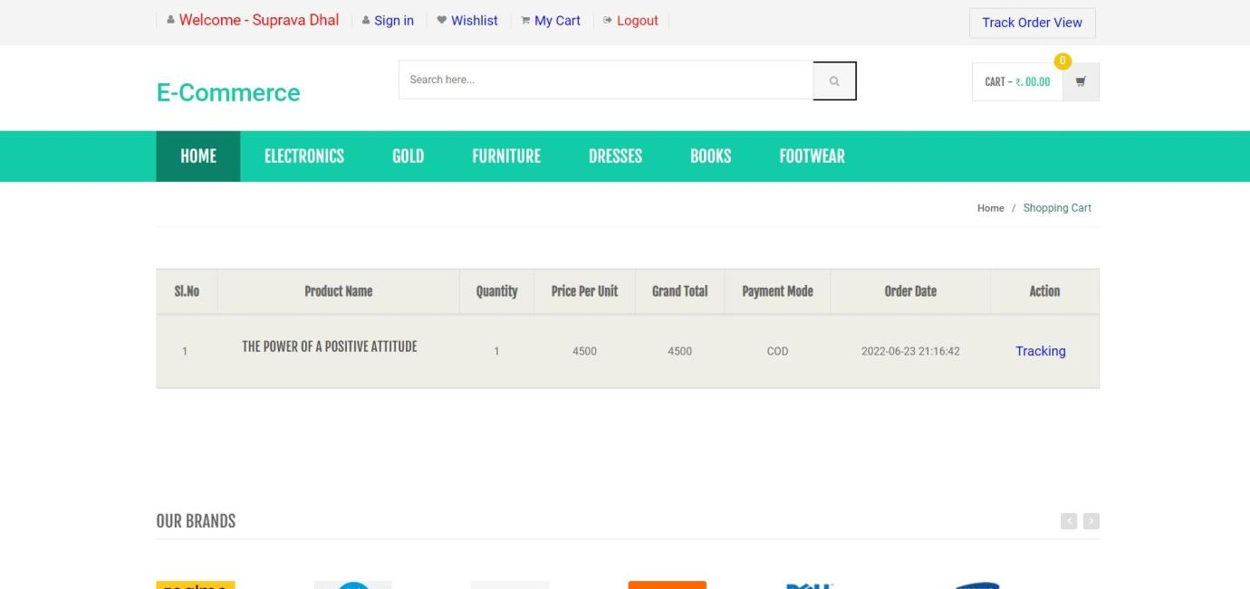

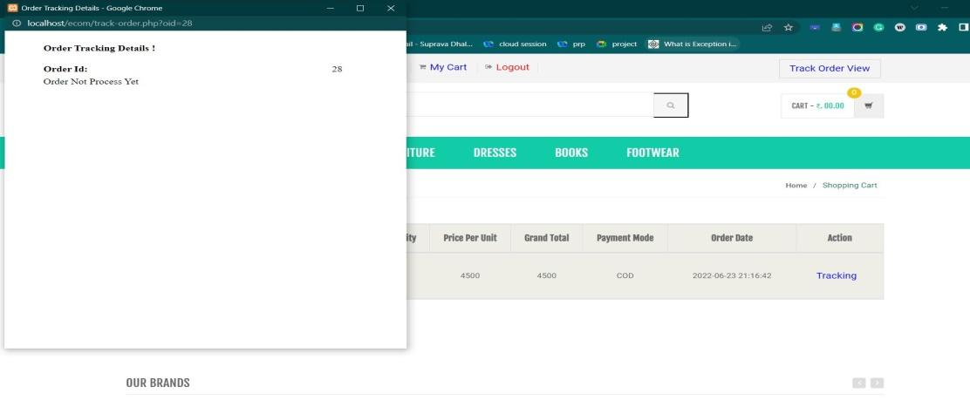

ADMIN-

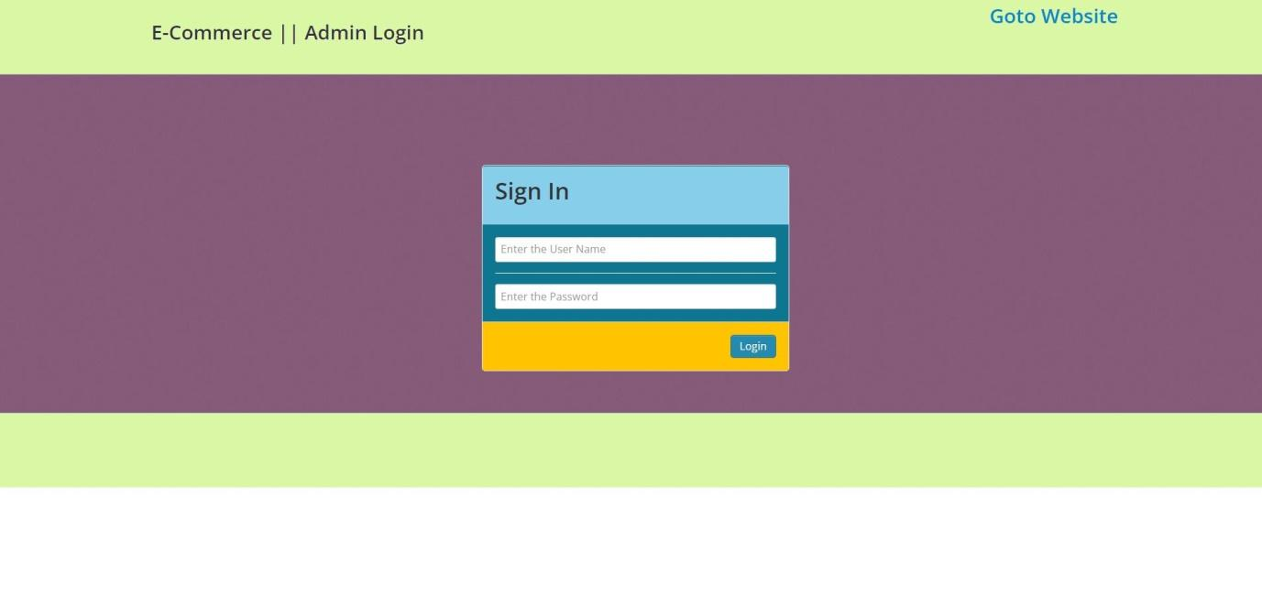

  Error Message-

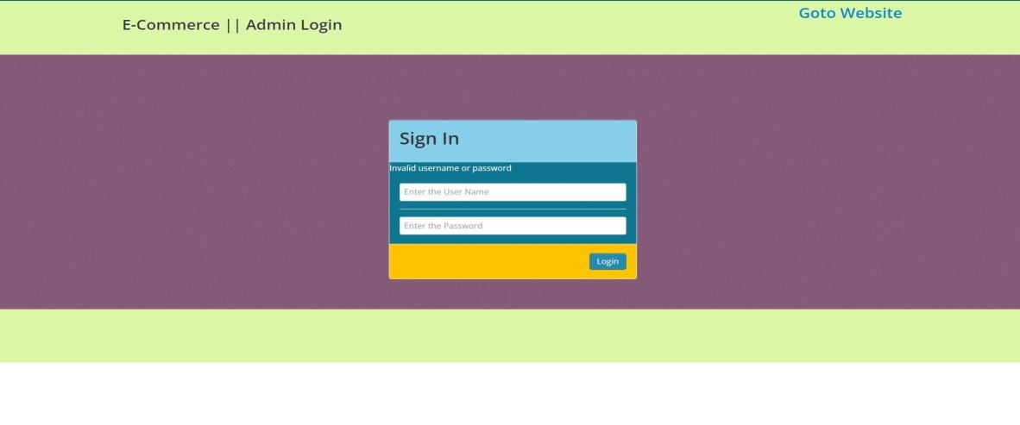

Admin password change-

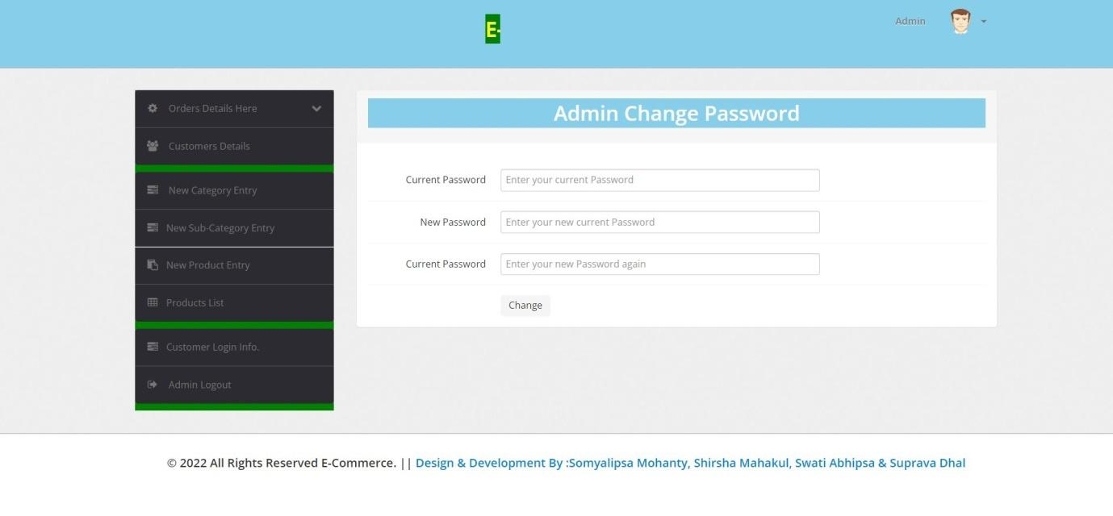

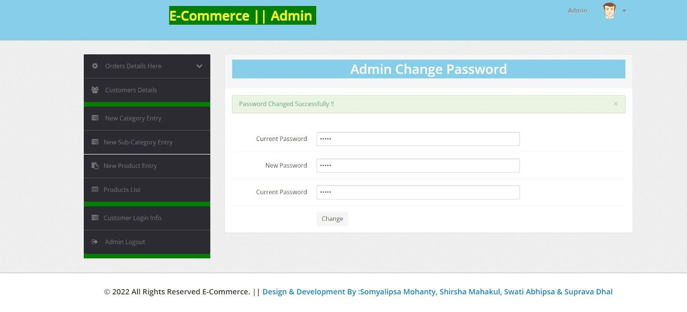

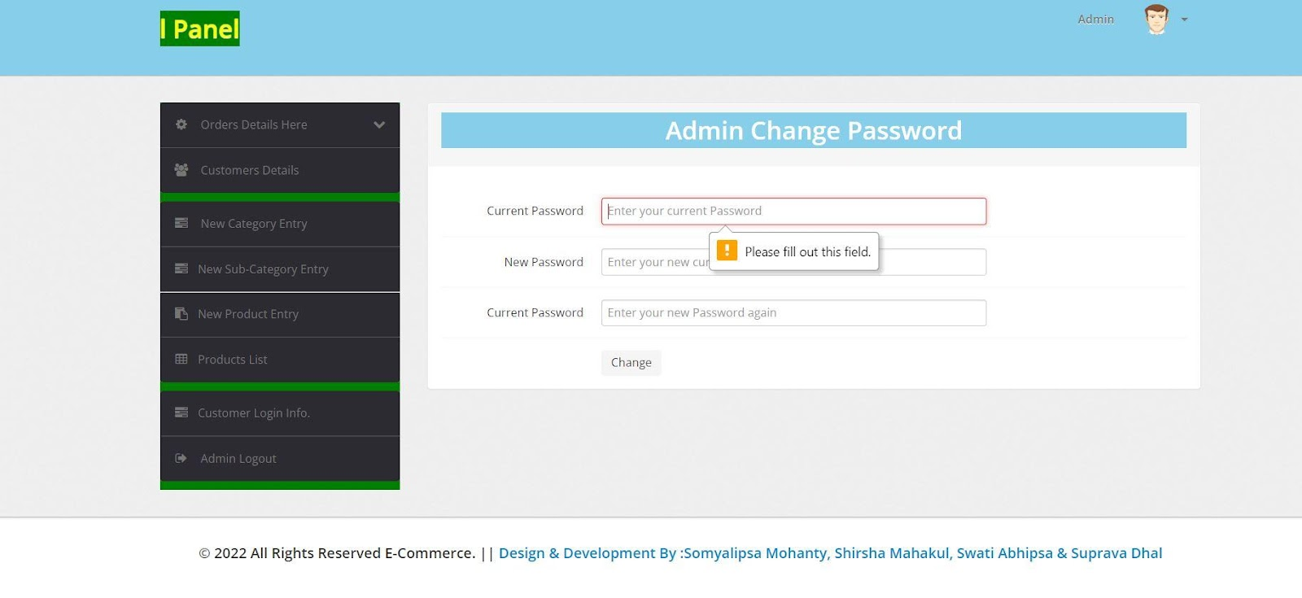

Today order list-

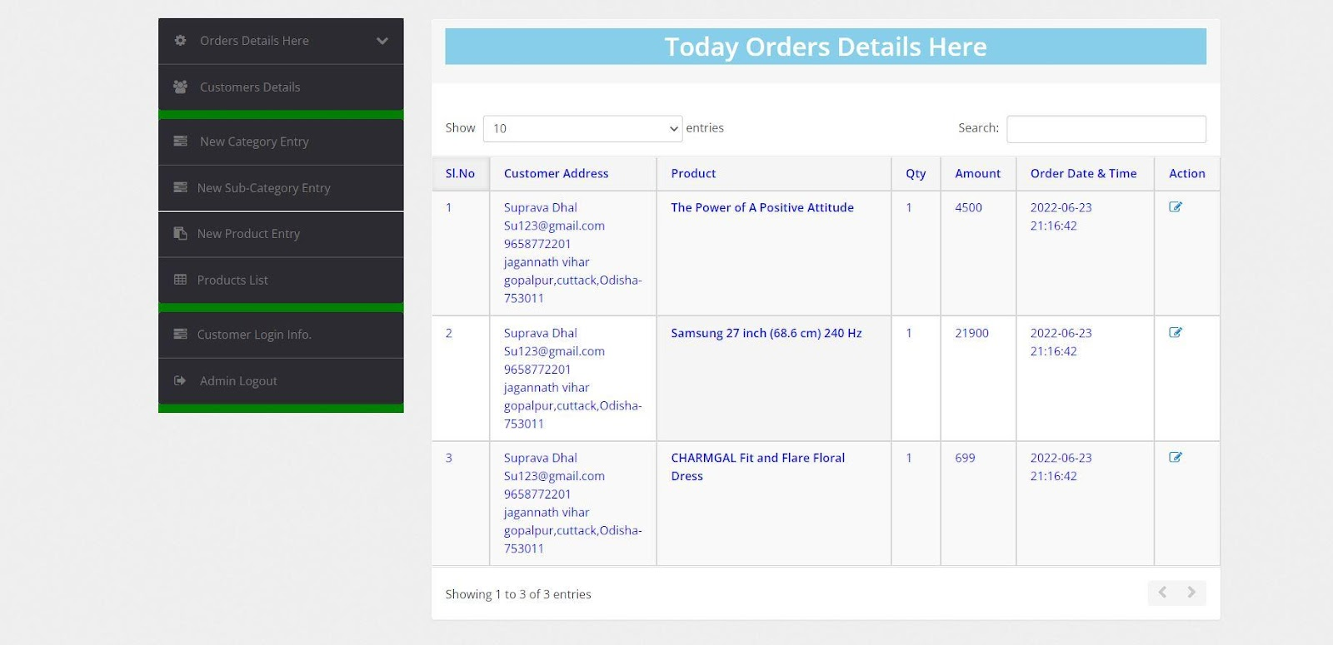

Update order-

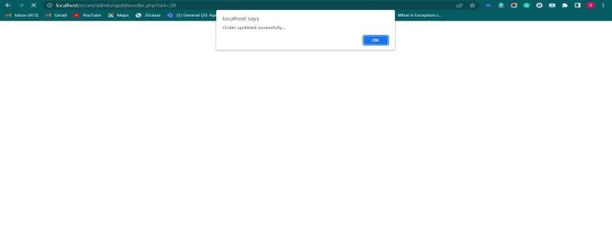

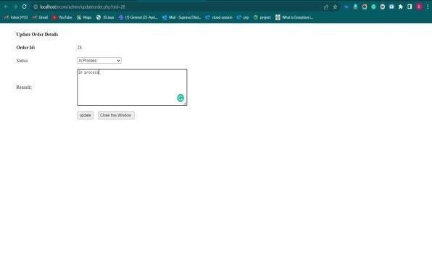

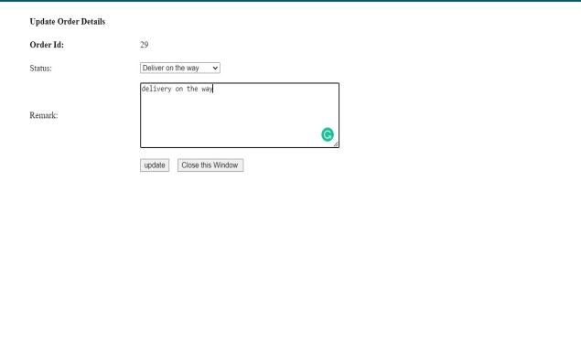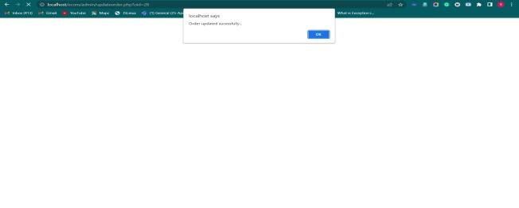

After Update In Admin Part In Customer Side-

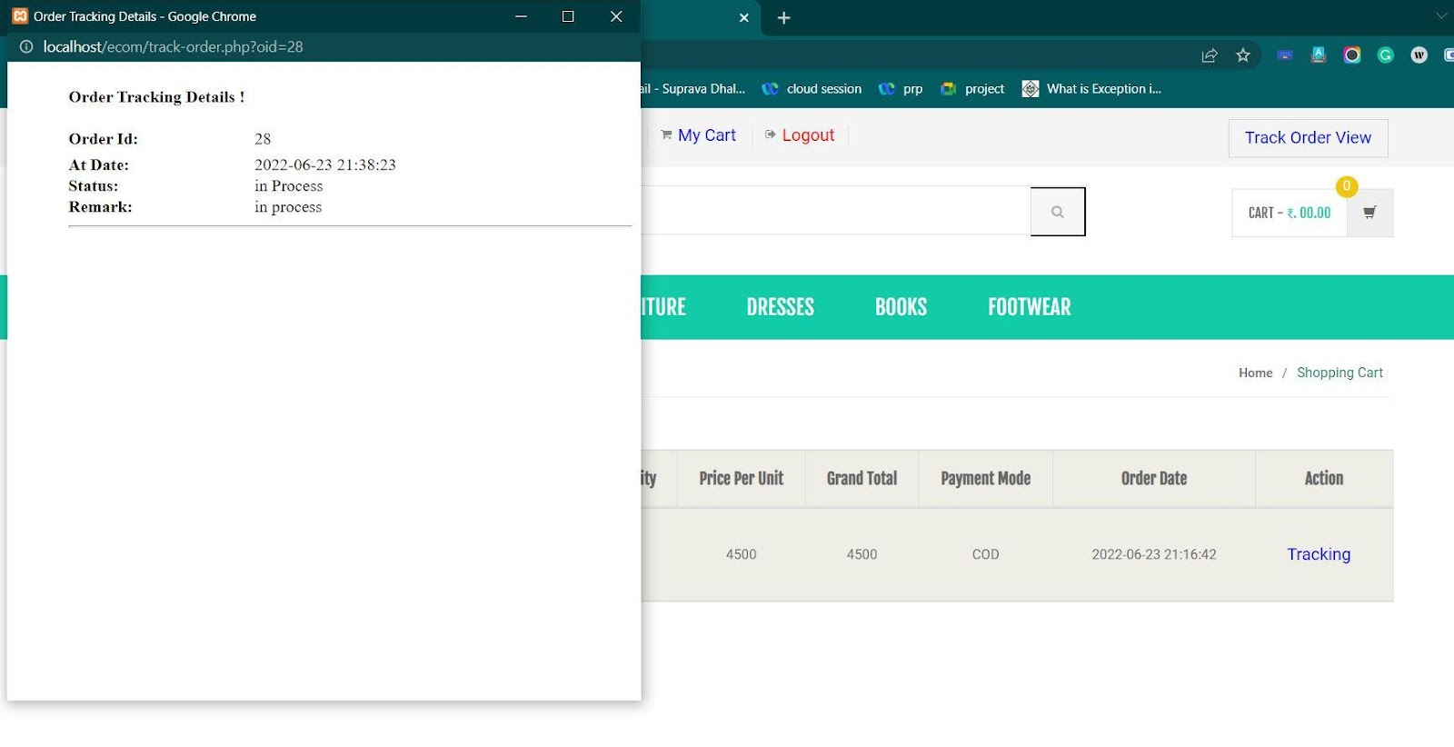

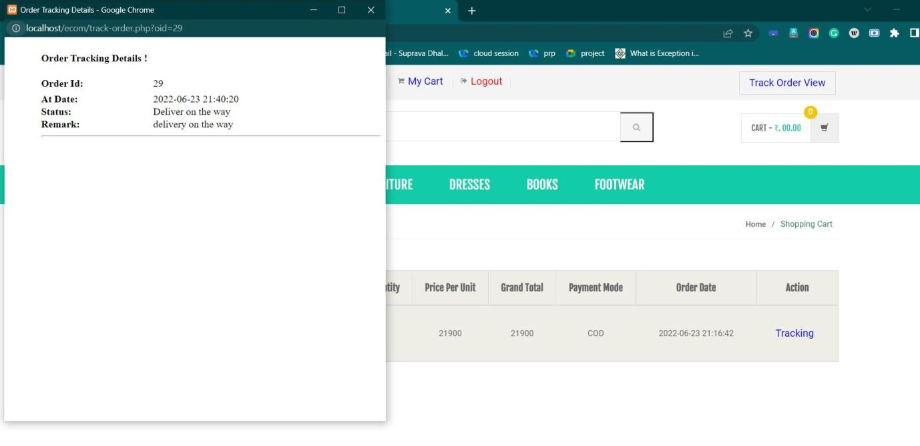

Customer Details-

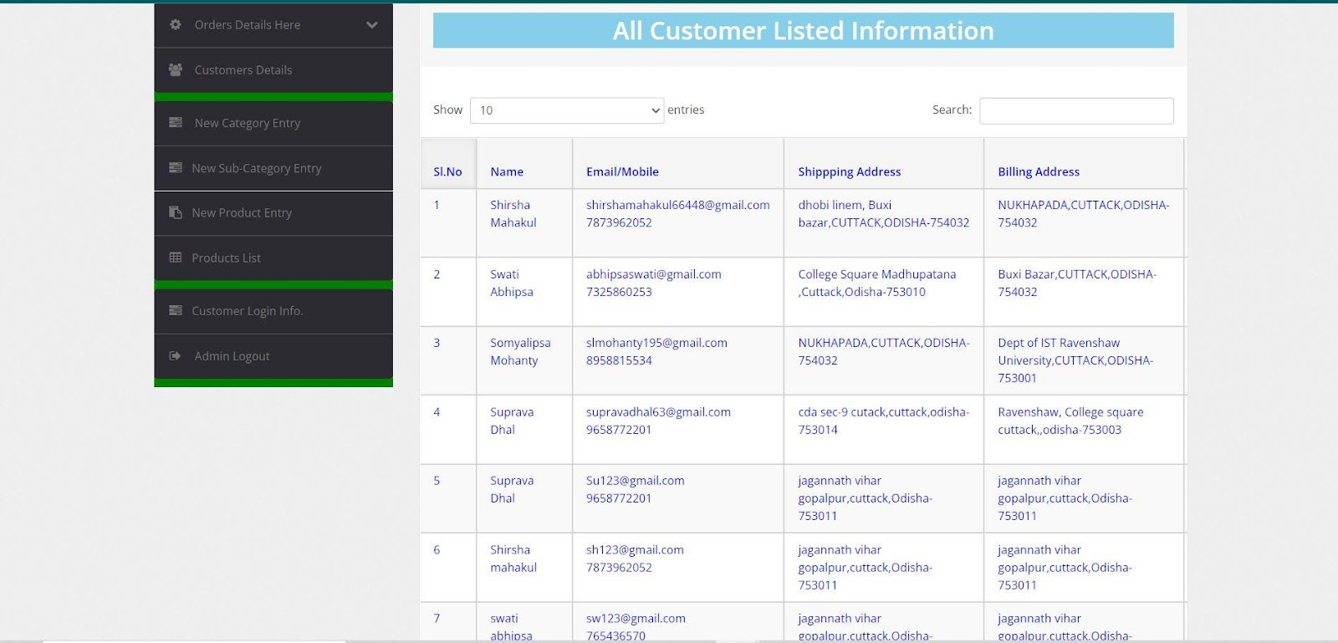

New Category-

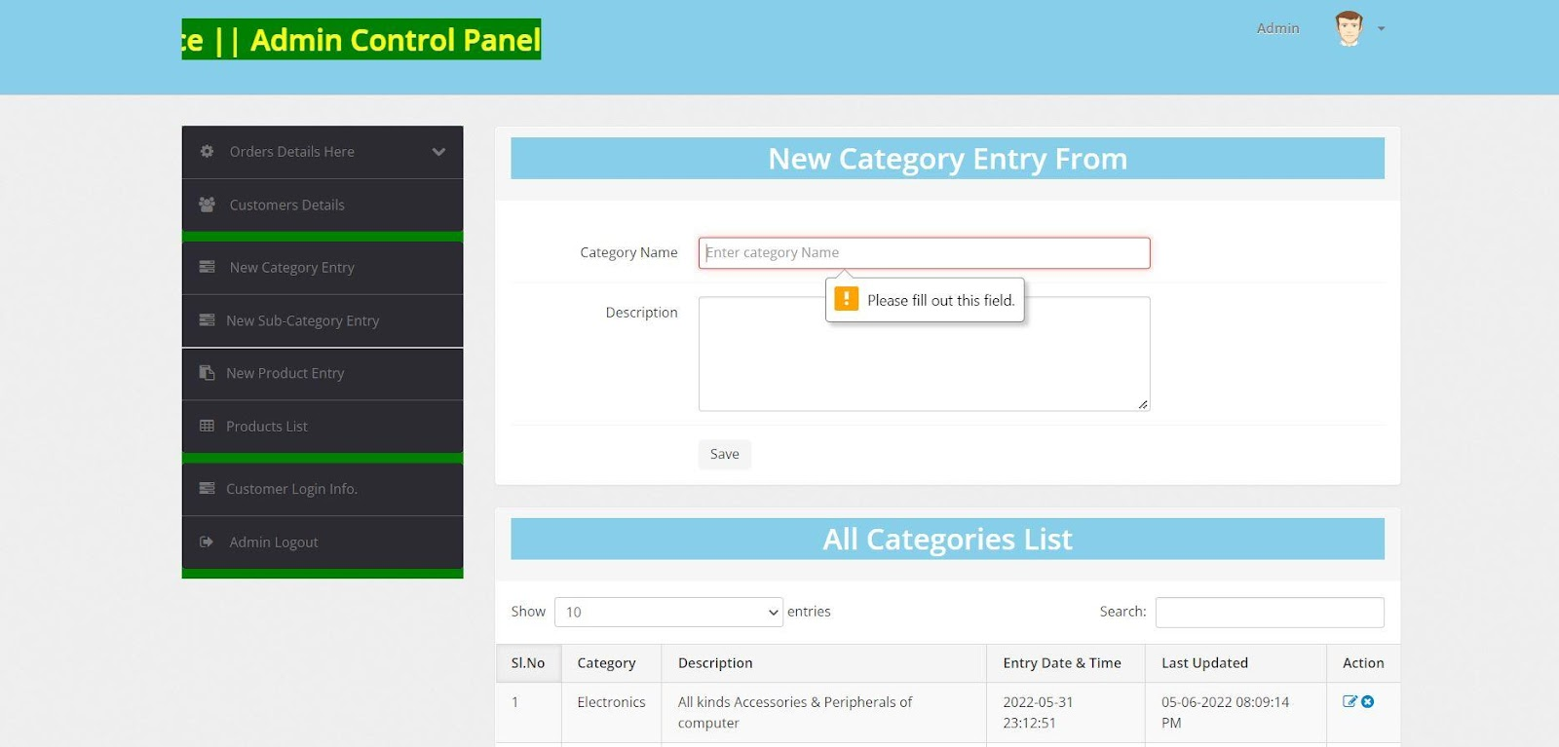

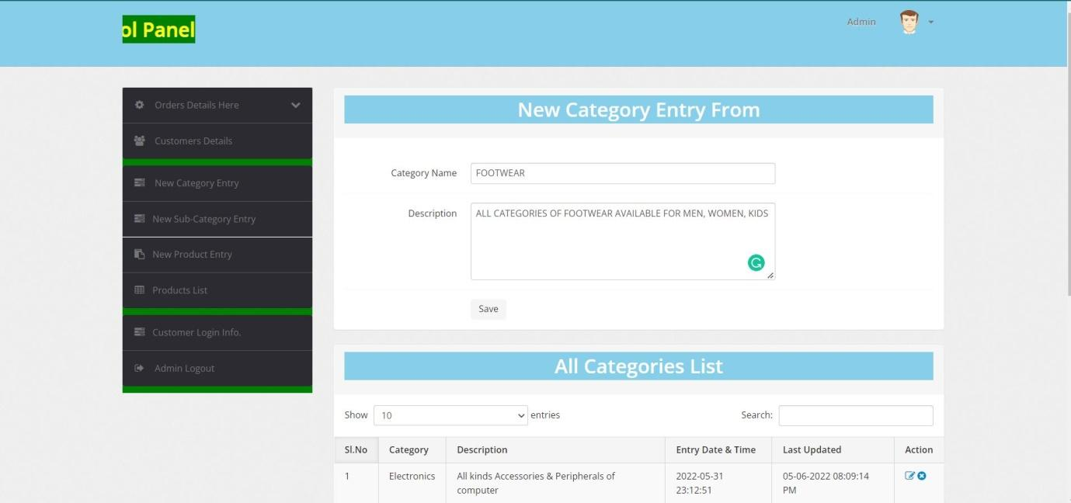

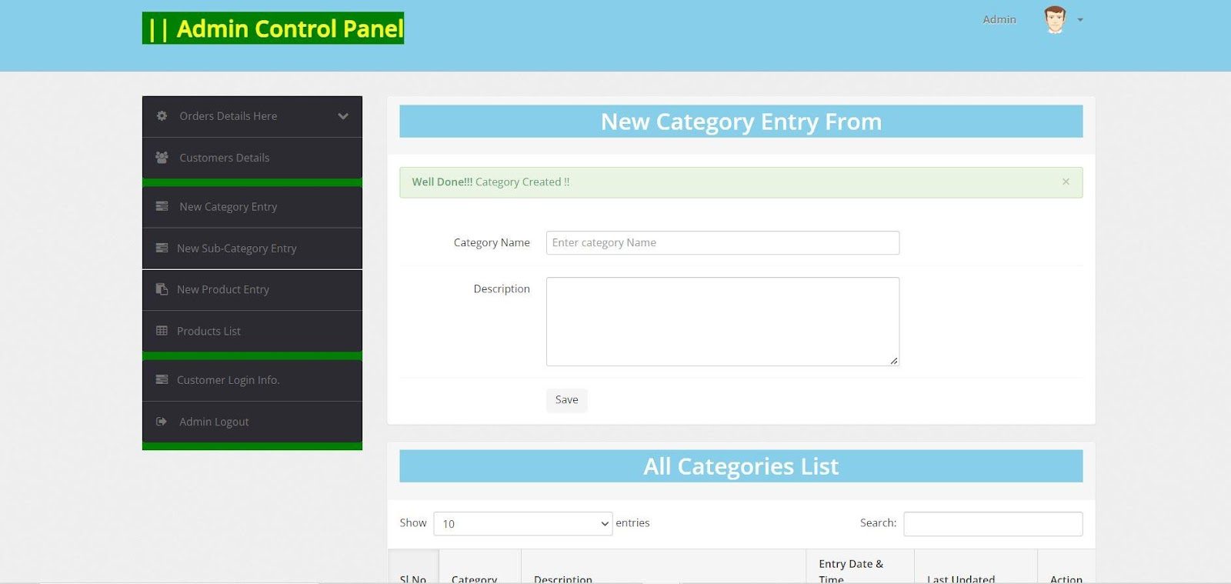

New Sub category-

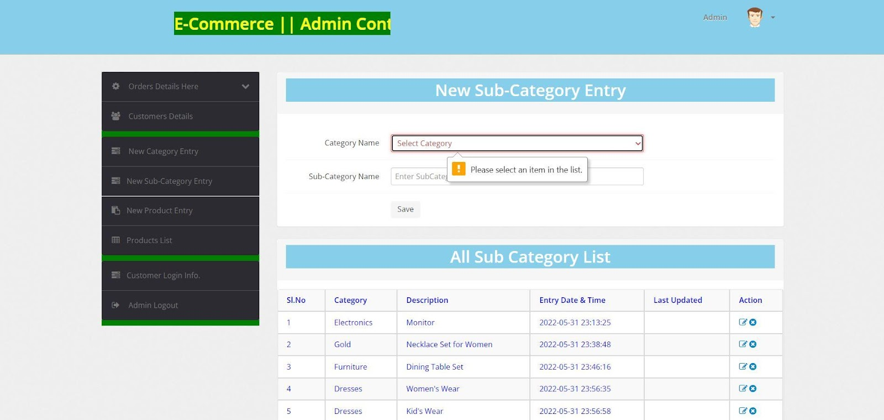

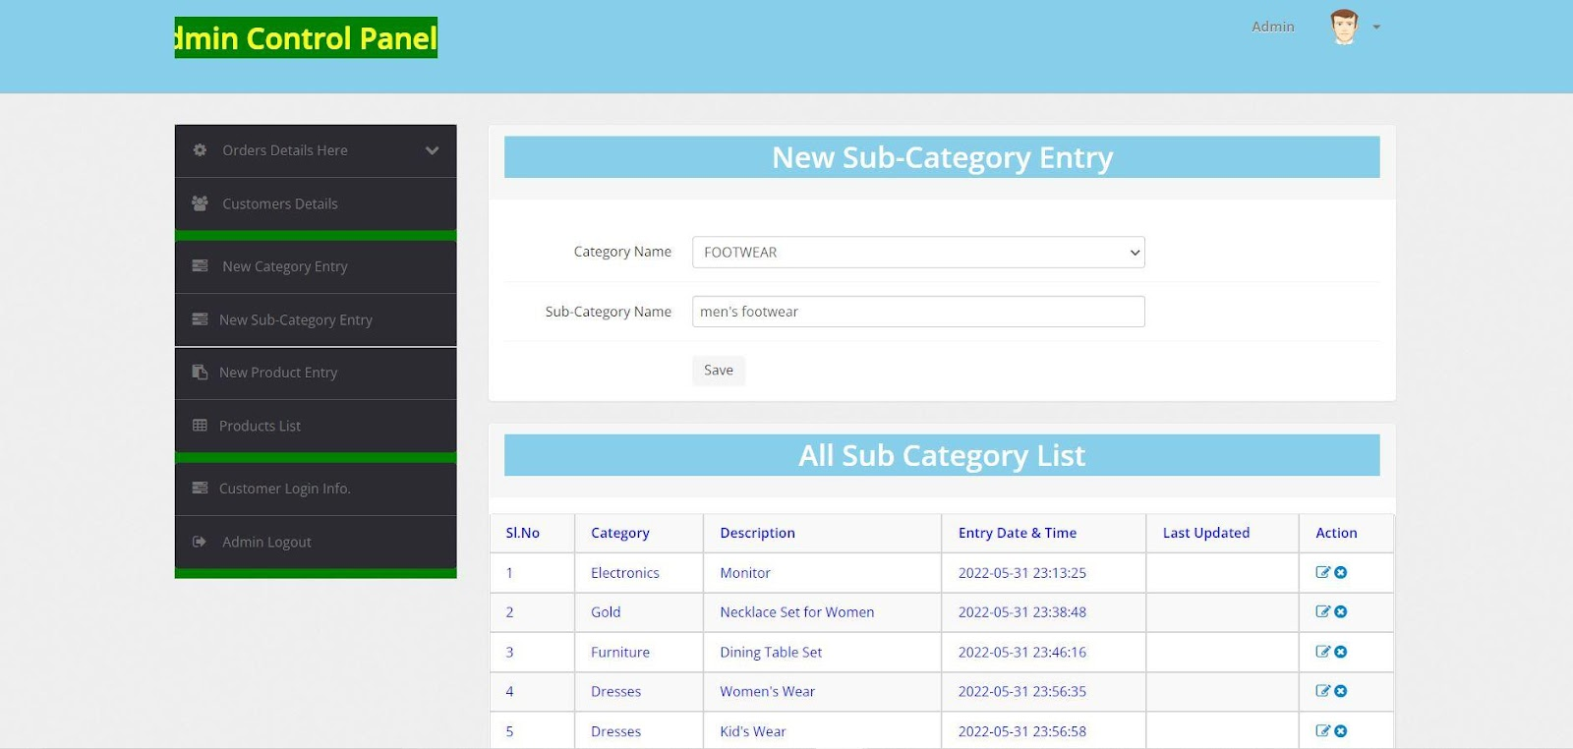

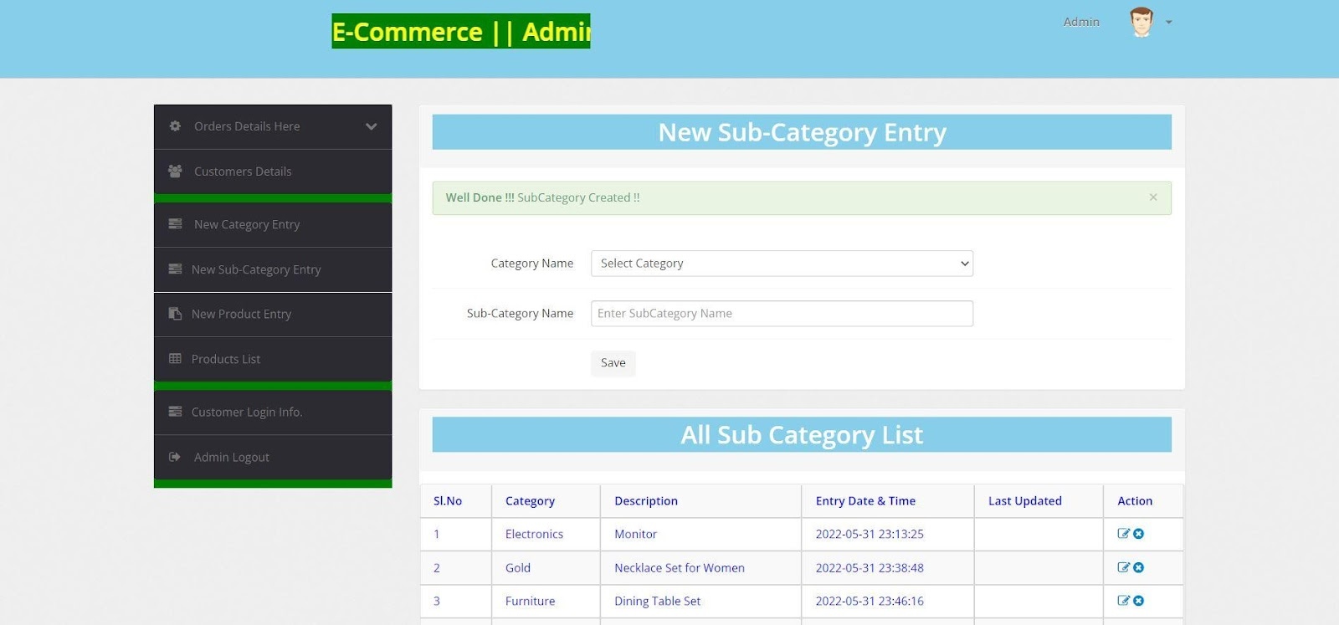

New Products-

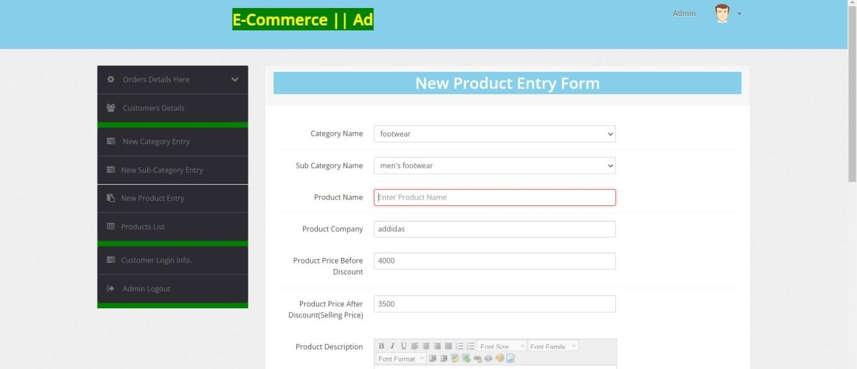

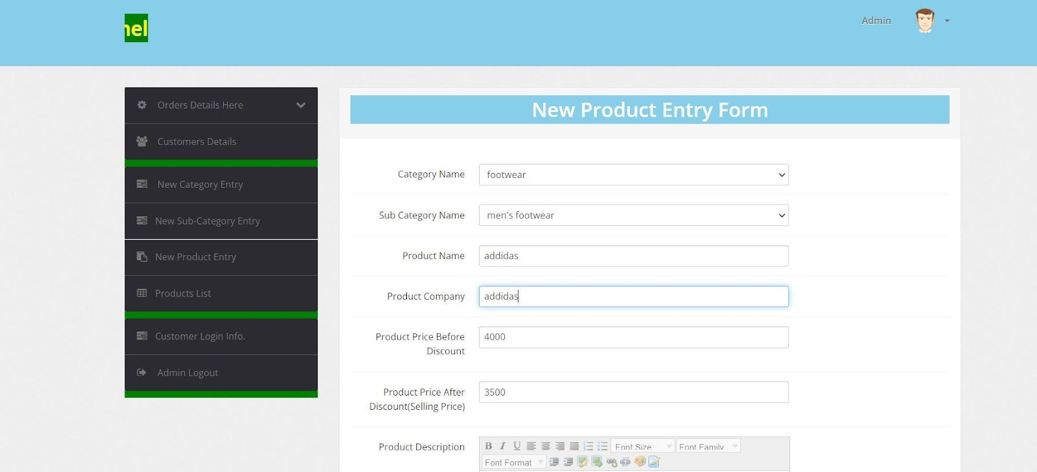

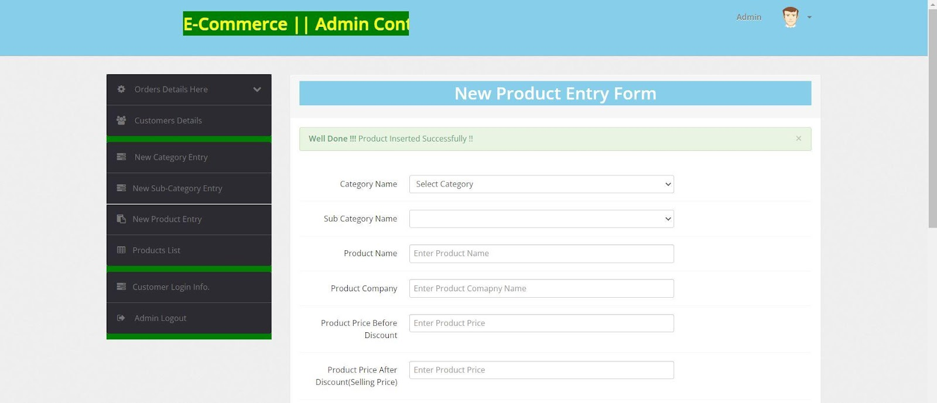

Product list –

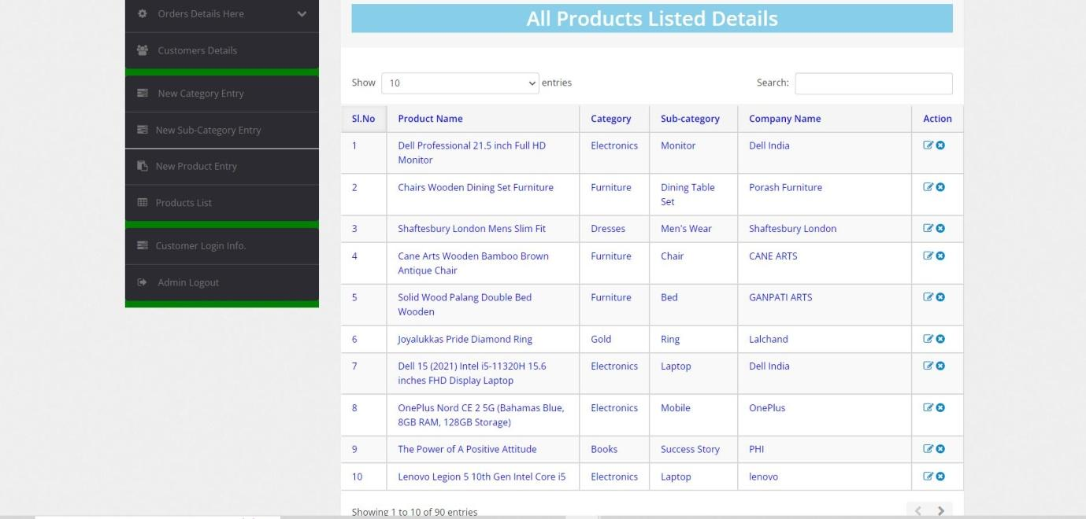

Update product-

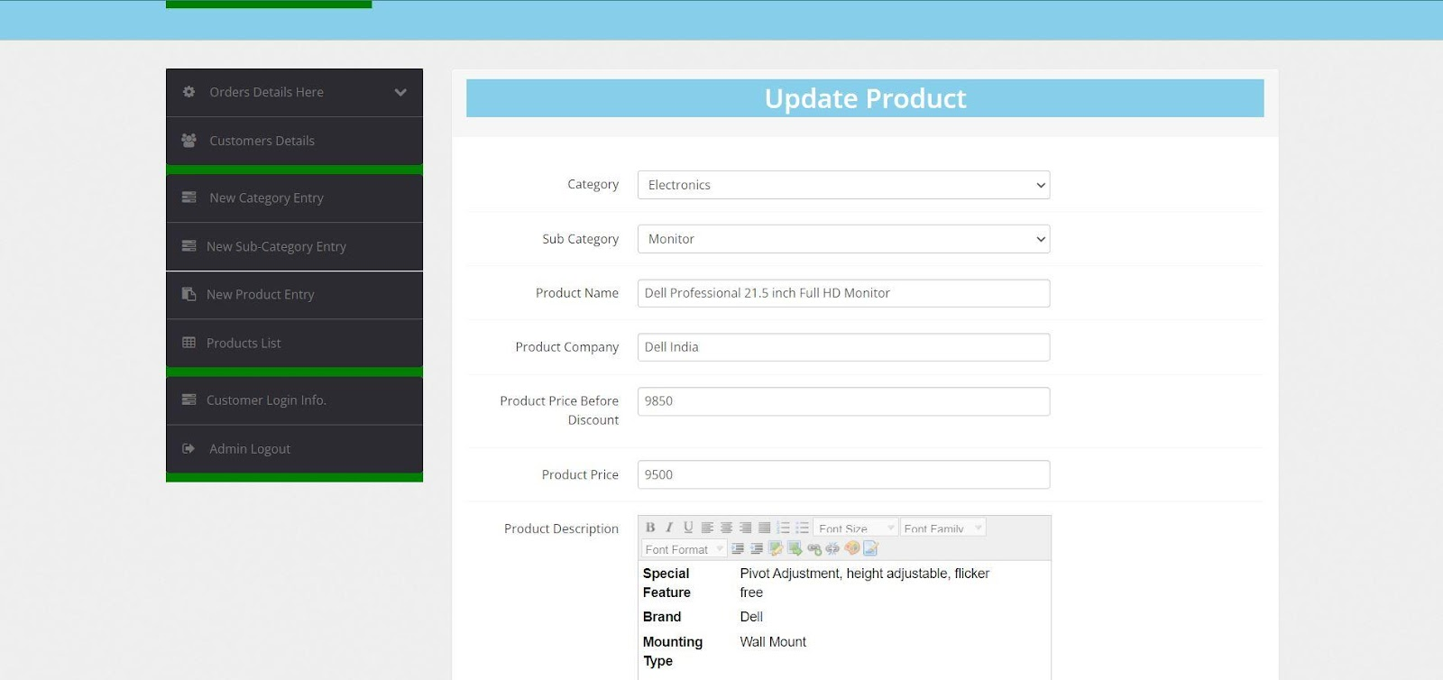

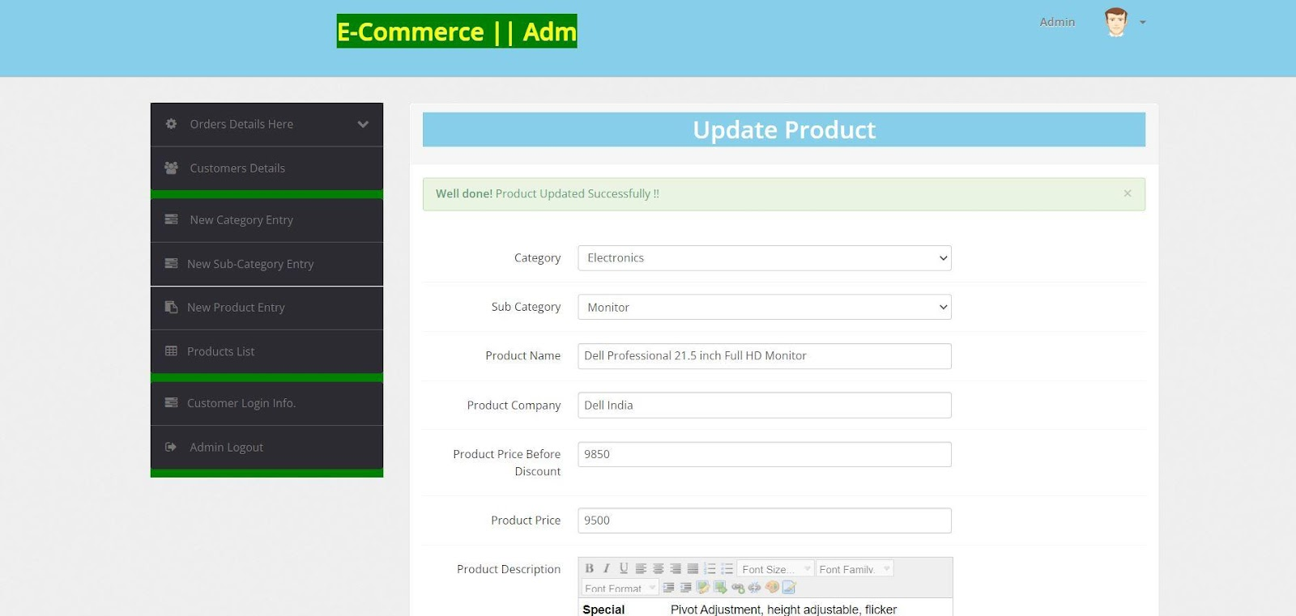

Customer login data-

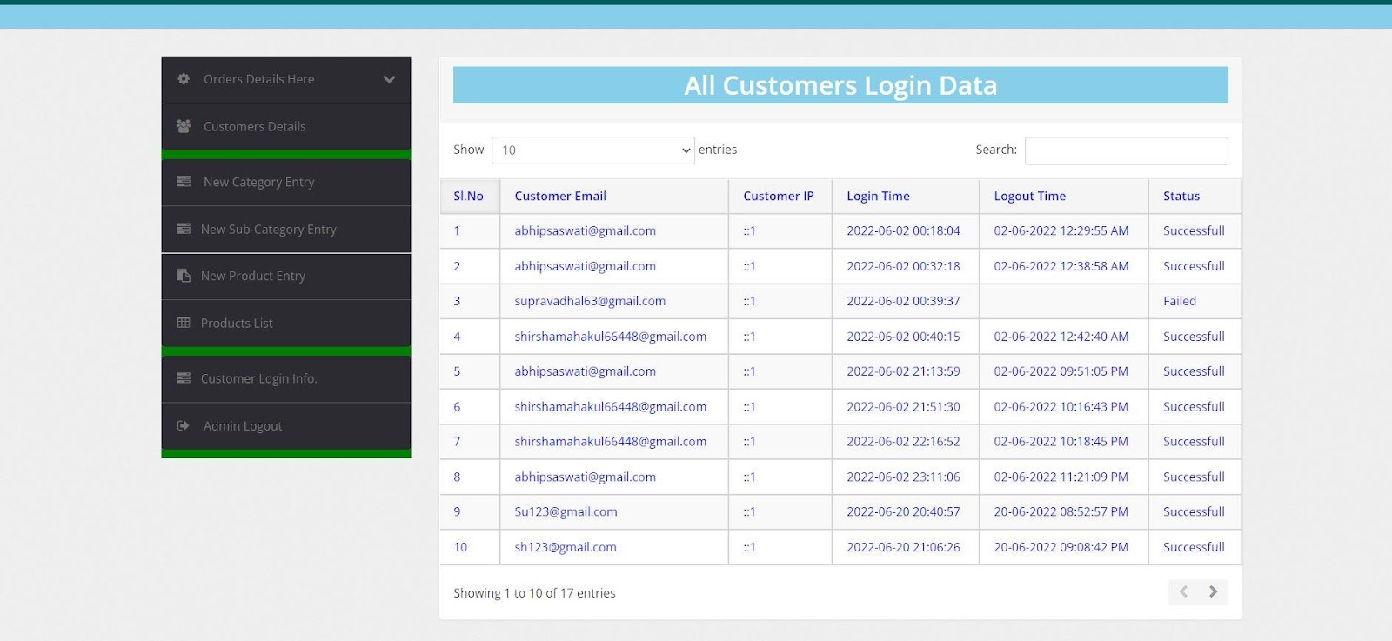

Coding of Part

**Index.php**

<?php

session_start();

error_reporting(0);

include('includes/config.php');

if(isset($_GET['action']) && $_GET['action']=="add"){

$id=intval($_GET['id']);

if(isset($_SESSION['cart'][$id])){

$_SESSION['cart'][$id]['quantity']++;

}else{

$sql_p="SELECT * FROM products WHERE id={$id}";

$query_p=mysqli_query($con,$sql_p);

if(mysqli_num_rows($query_p)!=0){

$row_p=mysqli_fetch_array($query_p);

$_SESSION['cart'][$row_p['id']]=array("quantity" => 1, "price" => $row_p['productPrice']);

}else{

$message="Product ID is invalid";

}

}

echo "<script>alert('Product has been added to the cart')</script>";

echo "<script type='text/javascript'> document.location ='my-cart.php'; </script>";

}

?>

<!DOCTYPE html>

<html lang="en">

<head>

<!-- Meta -->

<meta charset="utf-8">

<meta http-equiv="Content-Type" content="text/html; charset=UTF-8">

<meta name="viewport" content="width=device-width, initial-scale=1.0, user-scalable=no">

<meta name="description" content="">

<meta name="author" content="">

    <meta name="keywords" content="MediaCenter, Template, eCommerce">

    <meta name="robots" content="all">

    <title>E-Commerce Home </title>

    <!-- Bootstrap Core CSS -->

    <link rel="stylesheet" href="assets/css/bootstrap.min.css">

    <!-- Customizable CSS -->

    <link rel="stylesheet" href="assets/css/main.css">

    <link rel="stylesheet" href="assets/css/purple.css">

    <link rel="stylesheet" href="assets/css/owl.carousel.css">

<link rel="stylesheet" href="assets/css/owl.transitions.css">

<!--<link rel="stylesheet" href="assets/css/owl.theme.css">-->

<link href="assets/css/lightbox.css" rel="stylesheet">

<link rel="stylesheet" href="assets/css/animate.min.css">

<link rel="stylesheet" href="assets/css/rateit.css">

<link rel="stylesheet" href="assets/css/bootstrap-select.min.css">

<!-- Demo Purpose Only. Should be removed in production -->

<link rel="stylesheet" href="assets/css/config.css">

<link href="assets/css/green.css" rel="alternate stylesheet" title="Green color">

<link href="assets/css/blue.css" rel="alternate stylesheet" title="Blue color">

<link href="assets/css/red.css" rel="alternate stylesheet" title="Red color">

<link href="assets/css/orange.css" rel="alternate stylesheet" title="Orange color">

<link href="assets/css/dark-green.css" rel="alternate stylesheet" title="Darkgreen color">

<link rel="stylesheet" href="assets/css/font-awesome.min.css">

<link href='http://fonts.googleapis.com/css?family=Roboto:300,400,500,700' rel='stylesheet' type='text/css'>

<!-- Favicon -->

<link rel="shortcut icon" href="assets/images/favicon.ico">

</head>

    <body class="cnt-home">

<div id="hero" class="homepage-slider3">

<div id="owl-main" class="owl-carousel owl-inner-nav owl-ui-sm">

  <div class="full-width-slider">

<div class="item full-width-slider" style="background-image: url(assets/images/sliders/slider8.jpg);">

</div>

</div>

      <div class="full-width-slider">

<div class="item" style="background-image: url(assets/images/sliders/slider2.png);">

</div>

</div>

    <div class="full-width-slider">

<div class="item" style="background-image: url(assets/images/sliders/slider7.jpg);">

</div>

</div>

<div class="full-width-slider">

<div class="item" style="background-image: url(assets/images/sliders/slider1.png);">

</div>

</div>

    <div class="full-width-slider">

<div class="item full-width-slider" style="background-image: url(assets/images/sliders/slider6.jpg);">

</div>

</div>

    <div class="full-width-slider">

<div class="item full-width-slider" style="background-image: url(assets/images/sliders/slider9.jpg);">

</div>

</div>

    <div class="full-width-slider">

<div class="item full-width-slider" style="background-image: url(assets/images/sliders/slider10.jpg);">

</div>

</div>

</div>

</div>

<!-- ========================================= SECTION – HERO : END ========================================= -->

<!-- ============================================== INFO BOXES ============================================== -->

<div class="info-boxes wow fadeInUp">

<div class="info-boxes-inner">

<div class="row">

<div class="col-md-6 col-sm-4 col-lg-4">

<div class="info-box">

<div class="row">

<div class="col-xs-2">

<H1 style="color:red; text-align:center;">&#8377; </H1>

</div>

<div class="col-xs-10">

<h4 class="info-box-heading blue">Money Back</h4>

</div>

</div>

<h6 class="text">15 Day Money Back Guarantee.</h6>

</div>

</div><!-- .col -->

<div class="hidden-md col-sm-4 col-lg-4">

<div class="info-box">

<div class="row">

<div class="col-xs-2">

<i class="icon fa fa-truck"></i>

</div>

<div class="col-xs-10">

<h4 class="info-box-heading green">free shipping</h4>

</div>

</div>

<h6 class="text">free ship-on oder over &#8377; 1999/-</h6>

</div>

</div><!-- .col -->

<div class="col-md-6 col-sm-4 col-lg-4">

<div class="info-box">

<div class="row">

<div class="col-xs-2">

<i class="icon fa fa-gift"></i>

</div>

<div class="col-xs-10">

<h4 class="info-box-heading red">Raja Discount</h4>

</div>

</div>

<h6 class="text">All items-sale up to 30% off </h6>

</div>

</div><!-- .col -->

</div><!-- /.row -->

</div><!-- /.info-boxes-inner -->

</div><!-- /.info-boxes -->

<!-- ============================================== INFO BOXES : END ============================================== -->

</div><!-- /.homebanner-holder -->

</div><!-- /.row -->

<!-- ============================================== SCROLL TABS ============================================== -->

<div id="product-tabs-slider" class="scroll-tabs inner-bottom-vs  wow fadeInUp">

<!--div class="more-info-tab clearfix">

  <h3 class="new-product-title pull-left">Featured Products</h3>

<ul class="nav nav-tabs nav-tab-line pull-right" id="new-products-1">

<li class="active"><a href="#all" data-toggle="tab">All</a></li>

<li><a href="#books" data-toggle="tab">Books</a></li>

<li><a href="#furniture" data-toggle="tab">Furniture</a></li>

</ul><!-- /.nav-tabs -->

</div-->

<div class="tab-content outer-top-xs">

<div class="tab-pane in active" id="all">

<div class="product-slider">

<div class="owl-carousel home-owl-carousel custom-carousel owl-theme" data-item="4">

<?php

$ret=mysqli_query($con,"select * from products");

while ($row=mysqli_fetch_array($ret))

{

# code...

?>

<div class="item item-carousel">

<div class="products">

<div class="product">

<div class="product-image">

<div class="image">

<a href="product-details.php?pid=<?php echo htmlentities($row['id']);?>">

<img  src="admin/productimages/<?php echo htmlentities($row['id']);?>/<?php echo htmlentities($row['productImage1']);?>" data-echo="admin/productimages/<?php echo htmlentities($row['id']);?>/<?php echo htmlentities($row['productImage1']);?>"  width="180" height="300" alt=""></a>

</div><!-- /.image -->

</div><!-- /.product-image -->

<div class="product-info text-left">

<h3 class="name"><a href="product-details.php?pid=<?php echo htmlentities($row['id']);?>"><?php echo htmlentities($row['productName']);?></a></h3>

<div class="rating rateit-small"></div>

<div class="description"></div>

<div class="product-price">

<span class="price">

&#8377;<?php echo htmlentities($row['productPrice']);?> </span>

    <span class="price-before-discount">&#8377;<?php echo htmlentities($row['productPriceBeforeDiscount']);?> </span>

</div><!-- /.product-price -->

</div><!-- /.product-info -->

<?php if($row['productAvailability']=='In Stock'){?>

<div class="action"><a href="index.php?page=product&action=add&id=<?php echo $row['id']; ?>" class="lnk btn btn-primary">Add to Cart</a></div>

<?php } else {?>

<div class="action" style="color:red">Out of Stock</div>

<?php } ?>

</div><!-- /.product -->

</div><!-- /.products -->

</div><!-- /.item -->

<?php } ?>

</div><!-- /.home-owl-carousel -->

</div><!-- /.product-slider -->

</div>

<div class="tab-pane" id="books">

<div class="product-slider">

<div class="owl-carousel home-owl-carousel custom-carousel owl-theme">

<?php

$ret=mysqli_query($con,"select * from products where category=3");

while ($row=mysqli_fetch_array($ret))

{

# code...

?>

<div class="item item-carousel">

<div class="products">

<div class="product">

<div class="product-image">

<div class="image">

<a href="product-details.php?pid=<?php echo htmlentities($row['id']);?>">

<img  src="admin/productimages/<?php echo htmlentities($row['id']);?>/<?php echo htmlentities($row['productImage1']);?>" data-echo="admin/productimages/<?php echo htmlentities($row['id']);?>/<?php echo htmlentities($row['productImage1']);?>"  width="180" height="300" alt=""></a>

</div><!-- /.image -->

</div><!-- /.product-image -->

<div class="product-info text-left">

<h3 class="name"><a href="product-details.php?pid=<?php echo htmlentities($row['id']);?>"><?php echo htmlentities($row['productName']);?></a></h3>

<div class="rating rateit-small"></div>

<div class="description"></div>

<div class="product-price">

<span class="price">

&#8377;  <?php echo htmlentities($row['productPrice']);?> </span>

    <span class="price-before-discount">&#8377;  <?php echo htmlentities($row['productPriceBeforeDiscount']);?></span>

</div><!-- /.product-price -->

</div><!-- /.product-info -->

<?php if($row['productAvailability']=='In Stock'){?>

<div class="action"><a href="index.php?page=product&action=add&id=<?php echo $row['id']; ?>" class="lnk btn btn-primary">Add to Cart</a></div>

<?php } else {?>

<div class="action" style="color:red">Out of Stock</div>

<?php } ?>

</div><!-- /.product -->

</div><!-- /.products -->

</div><!-- /.item -->

<?php } ?>

</div><!-- /.home-owl-carousel -->

</div><!-- /.product-slider -->

</div>

<div class="tab-pane" id="furniture">

<div class="product-slider">

<div class="owl-carousel home-owl-carousel custom-carousel owl-theme">

<?php

$ret=mysqli_query($con,"select * from products where category=5");

while ($row=mysqli_fetch_array($ret))

{

?>

<div class="item item-carousel">

<div class="products">

<div class="product">

<div class="product-image">

<div class="image">

<a href="product-details.php?pid=<?php echo htmlentities($row['id']);?>">

<img  src="admin/productimages/<?php echo htmlentities($row['id']);?>/<?php echo htmlentities($row['productImage1']);?>" data-echo="admin/productimages/<?php echo htmlentities($row['id']);?>/<?php echo htmlentities($row['productImage1']);?>"  width="180" height="300" alt=""></a>

</div>

</div>

<div class="product-info text-left">

<h3 class="name"><a href="product-details.php?pid=<?php echo htmlentities($row['id']);?>"><?php echo htmlentities($row['productName']);?></a></h3>

<div class="rating rateit-small"></div>

<div class="description"></div>

<div class="product-price">

<span class="price">

&#8377;  <?php echo htmlentities($row['productPrice']);?> </span>

    <span class="price-before-discount">&#8377;  <?php echo htmlentities($row['productPriceBeforeDiscount']);?></span>

</div>

</div>

<?php if($row['productAvailability']=='In Stock'){?>

<div class="action"><a href="index.php?page=product&action=add&id=<?php echo $row['id']; ?>" class="lnk btn btn-primary">Add to Cart</a></div>

<?php } else {?>

<div class="action" style="color:red">Out of Stock</div>

<?php } ?>

</div>

</div>

</div>

<?php } ?>

</div>

</div>

</div>

</div>

</div>

         <!-- ============================================== TABS ============================================== -->

<div class="sections prod-slider-small outer-top-small">

<div class="row">

<div class="col-md-6">

                  <section class="section">

                  <!--h3 class="section-title">Smart Phones</h3-->

                  <div class="owl-carousel homepage-owl-carousel custom-carousel outer-top-xs owl-theme" data-item="2">

<?php

$ret=mysqli_query($con,"select * from products where category=4 and subCategory=4");

while ($row=mysqli_fetch_array($ret))

{

?>

<div class="item item-carousel">

<div class="products">

<div class="product">

<div class="product-image">

<div class="image">

<a href="product-details.php?pid=<?php echo htmlentities($row['id']);?>"><img  src="admin/productimages/<?php echo htmlentities($row['id']);?>/<?php echo htmlentities($row['productImage1']);?>" data-echo="admin/productimages/<?php echo htmlentities($row['id']);?>/<?php echo htmlentities($row['productImage1']);?>"  width="180" height="300"></a>

</div><!-- /.image -->

</div><!-- /.product-image -->

<div class="product-info text-left">

<h3 class="name"><a href="product-details.php?pid=<?php echo htmlentities($row['id']);?>"><?php echo htmlentities($row['productName']);?></a></h3>

<div class="rating rateit-small"></div>

<div class="description"></div>

<div class="product-price">

<span class="price">

&#8377;   <?php echo htmlentities($row['productPrice']);?> </span>

    <span class="price-before-discount">&#8377;  <?php echo htmlentities($row['productPriceBeforeDiscount']);?></span>

</div>

</div>

<?php if($row['productAvailability']=='In Stock'){?>

<div class="action"><a href="index.php?page=product&action=add&id=<?php echo $row['id']; ?>" class="lnk btn btn-primary">Add to Cart</a></div>

<?php } else {?>

<div class="action" style="color:red">Out of Stock</div>

<?php } ?>

</div>

</div>

</div>

<?php }?>

                  </div>

                  </section>

</div>

<div class="col-md-6">

<section class="section">

<!--h3 class="section-title">Laptops</h3-->

                  <div class="owl-carousel homepage-owl-carousel custom-carousel outer-top-xs owl-theme" data-item="2">

<?php

$ret=mysqli_query($con,"select * from products where category=4 and subCategory=6");

while ($row=mysqli_fetch_array($ret))

{

?>

<div class="item item-carousel">

<div class="products">

<div class="product">

<div class="product-image">

<div class="image">

<a href="product-details.php?pid=<?php echo htmlentities($row['id']);?>"><img  src="admin/productimages/<?php echo htmlentities($row['id']);?>/<?php echo htmlentities($row['productImage1']);?>" data-echo="admin/productimages/<?php echo htmlentities($row['id']);?>/<?php echo htmlentities($row['productImage1']);?>"  width="300" height="300"></a>

</div><!-- /.image -->

</div><!-- /.product-image -->

<div class="product-info text-left">

<h3 class="name"><a href="product-details.php?pid=<?php echo htmlentities($row['id']);?>"><?php echo htmlentities($row['productName']);?></a></h3>

<div class="rating rateit-small"></div>

<div class="description"></div>

<div class="product-price">

<span class="price">

&#8377;  <?php echo htmlentities($row['productPrice']);?> </span>

    <span class="price-before-discount">&#8377;<?php echo htmlentities($row['productPriceBeforeDiscount']);?></span>

</div>

</div>

<?php if($row['productAvailability']=='In Stock'){?>

<div class="action"><a href="index.php?page=product&action=add&id=<?php echo $row['id']; ?>" class="lnk btn btn-primary">Add to Cart</a></div>

<?php } else {?>

<div class="action" style="color:red">Out of Stock</div>

<?php } ?>

</div>

</div>

</div>

<?php }?>

                  </div>

                  </section>

</div>

</div>

</div>

<!-- ============================================== TABS : END ============================================== -->

<section class="section featured-product inner-xs wow fadeInUp">

<!--h3 class="section-title">Fashion</h3-->

<div class="owl-carousel best-seller custom-carousel owl-theme outer-top-xs">

<?php

$ret=mysqli_query($con,"select * from products where category=6");

while ($row=mysqli_fetch_array($ret))

{

# code...

?>

<div class="item">

<div class="products">

<div class="product">

<div class="product-micro">

<div class="row product-micro-row">

<div class="col col-xs-6">

<div class="product-image">

<div class="image">

<a href="admin/productimages/<?php echo htmlentities($row['id']);?>/<?php echo htmlentities($row['productImage1']);?>" data-lightbox="image-1" data-title="<?php echo htmlentities($row['productName']);?>">

<img data-echo="admin/productimages/<?php echo htmlentities($row['id']);?>/<?php echo htmlentities($row['productImage1']);?>" width="170" height="174" alt="">

<div class="zoom-overlay"></div>

</a>

</div><!-- /.image -->

</div><!-- /.product-image -->

</div><!-- /.col -->

<div class="col col-xs-6">

<div class="product-info">

<h3 class="name"><a href="product-details.php?pid=<?php echo htmlentities($row['id']);?>"><?php echo htmlentities($row['productName']);?></a></h3>

<div class="rating rateit-small"></div>

<div class="product-price">

<span class="price">

&#8377;   <?php echo htmlentities($row['productPrice']);?>

</span>

</div><!-- /.product-price -->

<?php if($row['productAvailability']=='In Stock'){?>

<div class="action"><a href="index.php?page=product&action=add&id=<?php echo $row['id']; ?>" class="lnk btn btn-primary">Add to Cart</a></div>

<?php } else {?>

<div class="action" style="color:red">Out of Stock</div>

<?php } ?>

</div>

</div><!-- /.col -->

</div><!-- /.product-micro-row -->

</div><!-- /.product-micro -->

</div>

</div>

</div><?php } ?>

</div>

</section>

<?php include('includes/brands-slider.php');?>

</div>

<iframe src="https://www.google.com/maps/embed?pb=!1m18!1m12!1m3!1d7476.119374112782!2d85.89091557205276!3d20.46274154710381!2m3!1f0!2f0!3f0!3m2!1i1024!2i768!4f13.1!3m3!1m2!1s0x3a190d7a1828a07d%3A0xcff8ab08cafbb3a8!2sRavenshaw%20University%20Campus%2C%20Cuttack%2C%20Odisha%20753003!5e0!3m2!1sen!2sin!4v1654181505407!5m2!1sen!2sin" width="1200" height="450" style="border:0;" allowfullscreen="" loading="lazy" referrerpolicy="no-referrer-when-downgrade"></iframe>

</div>

<?php include('includes/footer.php');?>

<script src="assets/js/jquery-1.11.1.min.js"></script>

<script src="assets/js/bootstrap.min.js"></script>

<script src="assets/js/bootstrap-hover-dropdown.min.js"></script>

<script src="assets/js/owl.carousel.min.js"></script>

<script src="assets/js/echo.min.js"></script>

<script src="assets/js/jquery.easing-1.3.min.js"></script>

<script src="assets/js/bootstrap-slider.min.js"></script>

    <script src="assets/js/jquery.rateit.min.js"></script>

    <script type="text/javascript" src="assets/js/lightbox.min.js"></script>

    <script src="assets/js/bootstrap-select.min.js"></script>

    <script src="assets/js/wow.min.js"></script>

<script src="assets/js/scripts.js"></script>

<!-- For demo purposes – can be removed on production -->

<script src="switchstylesheet/switchstylesheet.js"></script>

<script>

$(document).ready(function(){

$(".changecolor").switchstylesheet( { seperator:"color"} );

$('.show-theme-options').click(function(){

$(this).parent().toggleClass('open');

return false;

});

});

$(window).bind("load", function() {

  $('.show-theme-options').delay(2000).trigger('click');

});

</script>

<!-- For demo purposes – can be removed on production : End -->

<div class="col-lg-12">

</div>

</body>

</html>

Login.php

<?php

session_start();

error_reporting(0);

include('includes/config.php');

// Code user Registration

if(isset($_POST['submit']))

{

$name=$_POST['fullname'];

$email=$_POST['emailid'];

$contactno=$_POST['contactno'];

$password=md5($_POST['password']);

$query=mysqli_query($con,"insert into users(name,email,contactno,password) values('$name','$email','$contactno','$password')");

if($query)

{

echo "<script>alert('You are successfully register');</script>";

}

else{

echo "<script>alert('Not register something went worng');</script>";

}

}

// Code for User login

if(isset($_POST['login']))

{

   $email=$_POST['email'];

   $password=md5($_POST['password']);

$query=mysqli_query($con,"SELECT * FROM users WHERE email='$email' and password='$password'");

$num=mysqli_fetch_array($query);

if($num>0)

{

$extra="my-cart.php";

$_SESSION['login']=$_POST['email'];

$_SESSION['id']=$num['id'];

$_SESSION['username']=$num['name'];

$uip=$_SERVER['REMOTE_ADDR'];

$status=1;

$log=mysqli_query($con,"insert into userlog(userEmail,userip,status) values('".$_SESSION['login']."','$uip','$status')");

$host=$_SERVER['HTTP_HOST'];

$uri=rtrim(dirname($_SERVER['PHP_SELF']),'/\\');

header("location:http://$host$uri/$extra");

exit();

}

else

{

$extra="login.php";

$email=$_POST['email'];

$uip=$_SERVER['REMOTE_ADDR'];

$status=0;

$log=mysqli_query($con,"insert into userlog(userEmail,userip,status) values('$email','$uip','$status')");

$host  = $_SERVER['HTTP_HOST'];

$uri  = rtrim(dirname($_SERVER['PHP_SELF']),'/\\');

header("location:http://$host$uri/$extra");

$_SESSION['errmsg']="Invalid email id or Password";

exit();

}

}

?>

<!DOCTYPE html>

<html lang="en">

<head>

<!-- Meta -->

<meta charset="utf-8">

<meta http-equiv="Content-Type" content="text/html; charset=UTF-8">

<meta name="viewport" content="width=device-width, initial-scale=1.0, user-scalable=no">

<meta name="description" content="">

<meta name="author" content="">

    <meta name="keywords" content="MediaCenter, Template, eCommerce">

    <meta name="robots" content="all">

    <title> Signi-in | Sign up</title>

    <!-- Bootstrap Core CSS -->

    <link rel="stylesheet" href="assets/css/bootstrap.min.css">

    <!-- Customizable CSS -->

    <link rel="stylesheet" href="assets/css/main.css">

    <link rel="stylesheet" href="assets/css/black.css">

    <link rel="stylesheet" href="assets/css/owl.carousel.css">

<link rel="stylesheet" href="assets/css/owl.transitions.css">

<!--<link rel="stylesheet" href="assets/css/owl.theme.css">-->

<link href="assets/css/lightbox.css" rel="stylesheet">

<link rel="stylesheet" href="assets/css/animate.min.css">

<link rel="stylesheet" href="assets/css/rateit.css">

<link rel="stylesheet" href="assets/css/bootstrap-select.min.css">

<!-- Demo Purpose Only. Should be removed in production -->

<link rel="stylesheet" href="assets/css/config.css">

<link href="assets/css/green.css" rel="alternate stylesheet" title="Green color">

<link href="assets/css/blue.css" rel="alternate stylesheet" title="Blue color">

<link href="assets/css/red.css" rel="alternate stylesheet" title="Red color">

<link href="assets/css/orange.css" rel="alternate stylesheet" title="Orange color">

<link href="assets/css/dark-green.css" rel="alternate stylesheet" title="Darkgreen color">

<!-- Demo Purpose Only. Should be removed in production : END -->

<!-- Icons/Glyphs -->

<link rel="stylesheet" href="assets/css/font-awesome.min.css">

        <!-- Fonts -->

<link href='http://fonts.googleapis.com/css?family=Roboto:300,400,500,700' rel='stylesheet' type='text/css'>

<!-- Favicon -->

<link rel="shortcut icon" href="assets/images/favicon.ico">

<script type="text/javascript">

function valid()

{

 if(document.register.password.value!= document.register.confirmpassword.value)

{

alert("Password and Confirm Password Field do not match  !!");

document.register.confirmpassword.focus();

return false;

}

return true;

}

</script>

     <script>

function userAvailability() {

$("#loaderIcon").show();

jQuery.ajax({

url: "check_availability.php",

data:'email='+$("#email").val(),

type: "POST",

success:function(data){

$("#user-availability-status1").html(data);

$("#loaderIcon").hide();

},

error:function (){}

});

}

</script>

</head>

    <body class="cnt-home">

<div class="breadcrumb">

<div class="container">

<div class="breadcrumb-inner">

<ul class="list-inline list-unstyled">

<li><a href="home.html">Home</a></li>

<li class='active'>Authentication</li>

</ul>

</div><!-- /.breadcrumb-inner -->

</div><!-- /.container -->

</div><!-- /.breadcrumb -->

<div class="body-content outer-top-bd">

<div class="container">

<div class="sign-in-page inner-bottom-sm">

<div class="row">

<!-- Sign-in -->

<div class="col-md-6 col-sm-6 sign-in" style=" background-color:#d1e0e0;" >

<h4 class="">Welcome to your account login here.</h4>

<form class="register-form outer-top-xs" method="post">

<span style="color:red;" >

<?php

echo htmlentities($_SESSION['errmsg']);

?>

<?php

echo htmlentities($_SESSION['errmsg']="");

?>

</span>

<div class="form-group">

    <label class="info-title" for="exampleInputEmail1">Email Address <span>*</span></label>

    <input type="email" name="email" class="form-control unicase-form-control text-input" id="exampleInputEmail1" >

</div>

  <div class="form-group">

    <label class="info-title" for="exampleInputPassword1">Password <span>*</span></label>

<input type="password" name="password" class="form-control unicase-form-control text-input" id="exampleInputPassword1" >

</div>

<div class="radio outer-xs">

  <a href="forgot-password.php" class="forgot-password pull-right"><font color="red" size="4">Forgot your Password?</font></a>

  <button type="submit" class="btn-upper btn btn-primary checkout-page-button" name="login" style=" background-color:red;">Login</button>

</div>

</form>

</div>

<!-- Sign-in -->

<!-- create a new account -->

<div class="col-md-6 col-sm-6 create-new-account" style=" background-color: #ffcccc;">

<h4 class="checkout-subtitle">Create your own Account for Login.</h4>

<form class="register-form outer-top-xs" role="form" method="post" name="register" onSubmit="return valid();">

<div class="form-group">

    <label class="info-title" for="fullname">Full Name <span>*</span></label>

    <input type="text" class="form-control unicase-form-control text-input" id="fullname" name="fullname" required="required">

  </div>

<div class="form-group">

    <label class="info-title" for="exampleInputEmail2">Email Address <span>*</span></label>

    <input type="email" class="form-control unicase-form-control text-input" id="email" onBlur="userAvailability()" name="emailid" required >

          <span id="user-availability-status1" style="font-size:12px;"></span>

  </div>

<div class="form-group">

    <label class="info-title" for="contactno">Mobile No. <span>*</span></label>

    <input type="number" class="form-control unicase-form-control text-input" id="contactno" name="contactno" maxlength="10" required >

  </div>

<div class="form-group">

    <label class="info-title" for="password">Password. <span>*</span></label>

    <input type="password" class="form-control unicase-form-control text-input" id="password" name="password"  required >

  </div>

<div class="form-group">

    <label class="info-title" for="confirmpassword">Confirm Password. <span>*</span></label>

    <input type="password" class="form-control unicase-form-control text-input" id="confirmpassword" name="confirmpassword" required >

  </div>

  <button type="submit" name="submit" class="btn-upper btn btn-primary checkout-page-button" id="submit" style=" background-color:blue;">Register</button>

</form>

<span class="checkout-subtitle outer-top-xs">Sign Up Today And You'll Be Able To :  </span>

<div class="checkbox">

  <label class="checkbox">

  Speed your way through the checkout.

</label>

<label class="checkbox">

Track your orders easily.

</label>

<label class="checkbox">

 Keep a record of all your purchases.

</label>

</div>

</div>

<!-- create a new account --> </div><!-- /.row -->

</div>

<?php include('includes/brands-slider.php');?>

</div>

</div>

<?php include('includes/footer.php');?>

<script src="assets/js/jquery-1.11.1.min.js"></script>

<script src="assets/js/bootstrap.min.js"></script>

<script src="assets/js/bootstrap-hover-dropdown.min.js"></script>

<script src="assets/js/owl.carousel.min.js"></script>

<script src="assets/js/echo.min.js"></script>

<script src="assets/js/jquery.easing-1.3.min.js"></script>

<script src="assets/js/bootstrap-slider.min.js"></script>

    <script src="assets/js/jquery.rateit.min.js"></script>

    <script type="text/javascript" src="assets/js/lightbox.min.js"></script>

    <script src="assets/js/bootstrap-select.min.js"></script>

    <script src="assets/js/wow.min.js"></script>

<script src="assets/js/scripts.js"></script>

<!-- For demo purposes – can be removed on production -->

<script src="switchstylesheet/switchstylesheet.js"></script>

<script>

$(document).ready(function(){

$(".changecolor").switchstylesheet( { seperator:"color"} );

$('.show-theme-options').click(function(){

$(this).parent().toggleClass('open');

return false;

});

});

$(window).bind("load", function() {

  $('.show-theme-options').delay(2000).trigger('click');

});

</script>

<!-- For demo purposes – can be removed on production : End -->

</body>

</html>

**myaccount.php**

<?php

session_start();

error_reporting(0);

include('includes/config.php');

if(strlen($_SESSION['login'])==0)

    {

header('location:login.php');

}

else{

if(isset($_POST['update']))

{

$name=$_POST['name'];

$contactno=$_POST['contactno'];

$query=mysqli_query($con,"update users set name='$name',contactno='$contactno' where id='".$_SESSION['id']."'");

if($query)

{

echo "<script>alert('Your info has been updated');</script>";

}

}

date_default_timezone_set('Asia/Kolkata');// change according timezone

$currentTime = date( 'd-m-Y h:i:s A', time () );

if(isset($_POST['submit']))

{

$sql=mysqli_query($con,"SELECT password FROM  users where password='".md5($_POST['cpass'])."' && id='".$_SESSION['id']."'");

$num=mysqli_fetch_array($sql);

if($num>0)

{

 $con=mysqli_query($con,"update students set password='".md5($_POST['newpass'])."', updationDate='$currentTime' where id='".$_SESSION['id']."'");

echo "<script>alert('Password Changed Successfully !!');</script>";

}

else

{

echo "<script>alert('Current Password not match !!');</script>";

}

}

?>

<!DOCTYPE html>

<html lang="en">

<head>

<!-- Meta -->

<meta charset="utf-8">

<meta http-equiv="Content-Type" content="text/html; charset=UTF-8">

<meta name="viewport" content="width=device-width, initial-scale=1.0, user-scalable=no">

<meta name="description" content="">

<meta name="author" content="">

    <meta name="keywords" content="MediaCenter, Template, eCommerce">

    <meta name="robots" content="all">

    <title>My Account</title>

    <!-- Bootstrap Core CSS -->

    <link rel="stylesheet" href="assets/css/bootstrap.min.css">

    <!-- Customizable CSS -->

    <link rel="stylesheet" href="assets/css/main.css">

    <link rel="stylesheet" href="assets/css/green.css">

    <link rel="stylesheet" href="assets/css/owl.carousel.css">

<link rel="stylesheet" href="assets/css/owl.transitions.css">

<!--<link rel="stylesheet" href="assets/css/owl.theme.css">-->

<link href="assets/css/lightbox.css" rel="stylesheet">

<link rel="stylesheet" href="assets/css/animate.min.css">

<link rel="stylesheet" href="assets/css/rateit.css">

<link rel="stylesheet" href="assets/css/bootstrap-select.min.css">

<!-- Demo Purpose Only. Should be removed in production -->

<link rel="stylesheet" href="assets/css/config.css">

<link href="assets/css/green.css" rel="alternate stylesheet" title="Green color">

<link href="assets/css/blue.css" rel="alternate stylesheet" title="Blue color">

<link href="assets/css/red.css" rel="alternate stylesheet" title="Red color">

<link href="assets/css/orange.css" rel="alternate stylesheet" title="Orange color">

<link href="assets/css/dark-green.css" rel="alternate stylesheet" title="Darkgreen color">

<link rel="stylesheet" href="assets/css/font-awesome.min.css">

<link href='http://fonts.googleapis.com/css?family=Roboto:300,400,500,700' rel='stylesheet' type='text/css'>

<link rel="shortcut icon" href="assets/images/favicon.ico">

<script type="text/javascript">

function valid()

{

if(document.chngpwd.cpass.value=="")

{

alert("Current Password Filed is Empty !!");

document.chngpwd.cpass.focus();

return false;

}

else if(document.chngpwd.newpass.value=="")

{

alert("New Password Filed is Empty !!");

document.chngpwd.newpass.focus();

return false;

}

else if(document.chngpwd.cnfpass.value=="")

{

alert("Confirm Password Filed is Empty !!");

document.chngpwd.cnfpass.focus();

return false;

}

else if(document.chngpwd.newpass.value!= document.chngpwd.cnfpass.value)

{

alert("Password and Confirm Password Field do not match  !!");

document.chngpwd.cnfpass.focus();

return false;

}

return true;

}

</script>

</head>

    <body class="cnt-home">

<header class="header-style-1">

<!-- ============================================== TOP MENU ============================================== -->

<?php include('includes/top-header.php');?>

<!-- ============================================== TOP MENU : END ============================================== -->

<?php include('includes/main-header.php');?>

<!-- ============================================== NAVBAR ============================================== -->

<?php include('includes/menu-bar.php');?>

<!-- ============================================== NAVBAR : END ============================================== -->

</header>

<!-- ============================================== HEADER : END ============================================== -->

<div class="breadcrumb">

<div class="container" >

<div class="breadcrumb-inner">

<ul class="list-inline list-unstyled">

<li><a href="#">Home</a></li>

<li class='active'>Checkout</li>

</ul>

</div><!-- /.breadcrumb-inner -->

</div><!-- /.container -->

</div><!-- /.breadcrumb -->

<div class="body-content outer-top-bd" style=" background-color:#b3cccc;">

<div class="container" style=" background-color:#ffece6;">

<div class="checkout-box inner-bottom-sm" >

<div class="row" >

<div class="col-md-8" >

<div class="panel-group checkout-steps" id="accordion" style=" background-color:red;">

<!-- checkout-step-01  -->

<div class="panel panel-default checkout-step-01" style=" background-color:#d1b3ff;">

<!-- panel-heading -->

<div class="panel-heading" style=" background-color:#b3e0ff;">

     <h4 class="unicase-checkout-title">

        <a data-toggle="collapse" class="" data-parent="#accordion" href="#collapseOne">

          <span>1</span>My Personal Profile

        </a>

    </h4>

    </div>

    <!-- panel-heading -->

<div id="collapseOne" class="panel-collapse collapse in" >

<!-- panel-body  -->

    <div class="panel-body" >

<div class="row">

<div class="col-md-12 col-sm-12 already-registered-login">

<?php

$query=mysqli_query($con,"select * from users where id='".$_SESSION['id']."'");

while($row=mysqli_fetch_array($query))

{

?>

<form class="register-form" role="form" method="post">

<div class="form-group"  >

    <label class="info-title" for="name">Name<span>*</span></label>

    <input type="text" class="form-control unicase-form-control text-input" value="<?php echo $row['name'];?>" id="name" name="name" required="required">

  </div>

<div class="form-group">

    <label class="info-title" for="exampleInputEmail1">Email Address <span>*</span></label>

<input type="email" class="form-control unicase-form-control text-input" id="exampleInputEmail1" value="<?php echo $row['email'];?>" readonly>

  </div>

  <div class="form-group">

    <label class="info-title" for="Contact No.">Mobile No. <span>*</span></label>

    <input type="text" class="form-control unicase-form-control text-input" id="contactno" name="contactno" required="required" value="<?php echo $row['contactno'];?>"  maxlength="10">

  </div>

  <button type="submit" name="update" class="btn-upper btn btn-primary checkout-page-button">Update</button>

</form>

<?php } ?>

</div>

<!-- already-registered-login -->

</div>

</div>

<!-- panel-body  -->

</div><!-- row -->

</div>

<!-- checkout-step-01  -->

    <!-- checkout-step-02  -->

  <div class="panel panel-default checkout-step-02" style=" background-color:#ffc6b3;">

    <div class="panel-heading" style=" background-color:#b3e0ff;">

      <h4 class="unicase-checkout-title">

        <a data-toggle="collapse" class="collapsed" data-parent="#accordion" href="#collapseTwo">

          <span>2</span>Change Password

        </a>

      </h4>

    </div>

    <div id="collapseTwo" class="panel-collapse collapse">

      <div class="panel-body">

<form class="register-form" role="form" method="post" name="chngpwd" onSubmit="return valid();">

                     <div class="form-group">

    <label class="info-title" for="Current Password">Current Password<span>*</span></label>

    <input type="password" class="form-control unicase-form-control text-input" id="cpass" name="cpass" required="required">

  </div>

<div class="form-group">

    <label class="info-title" for="New Password">New Password <span>*</span></label>

<input type="password" class="form-control unicase-form-control text-input" id="newpass" name="newpass">

  </div>

  <div class="form-group">

    <label class="info-title" for="Confirm Password">Confirm Password <span>*</span></label>

    <input type="password" class="form-control unicase-form-control text-input" id="cnfpass" name="cnfpass" required="required" >

  </div>

  <button type="submit" name="submit" class="btn-upper btn btn-primary checkout-page-button" style=" background-color:red;">Change </button>

</form>

  <!-- checkout-step-02  -->

</div><!-- /.checkout-steps -->

</div>

<?php include('includes/myaccount-sidebar.php');?>

</div><!-- /.row -->

</div><!-- /.checkout-box -->

<?php include('includes/brands-slider.php');?>

</div>

</div>

<?php include('includes/footer.php');?>

<script src="assets/js/jquery-1.11.1.min.js"></script>

<script src="assets/js/bootstrap.min.js"></script>

<script src="assets/js/bootstrap-hover-dropdown.min.js"></script>

<script src="assets/js/owl.carousel.min.js"></script>

<script src="assets/js/echo.min.js"></script>

<script src="assets/js/jquery.easing-1.3.min.js"></script>

<script src="assets/js/bootstrap-slider.min.js"></script>

    <script src="assets/js/jquery.rateit.min.js"></script>

    <script type="text/javascript" src="assets/js/lightbox.min.js"></script>

    <script src="assets/js/bootstrap-select.min.js"></script>

    <script src="assets/js/wow.min.js"></script>

<script src="assets/js/scripts.js"></script>

<!-- For demo purposes – can be removed on production -->

<script src="switchstylesheet/switchstylesheet.js"></script>

<script>

$(document).ready(function(){

$(".changecolor").switchstylesheet( { seperator:"color"} );

$('.show-theme-options').click(function(){

$(this).parent().toggleClass('open');

return false;

});

});

$(window).bind("load", function() {

  $('.show-theme-options').delay(2000).trigger('click');

});

</script>

</body>

</html>

<?php } ?>

**Payment.php**

<?php

session_start();

error_reporting(0);

include('includes/config.php');

if(strlen($_SESSION['login'])==0)

    {

header('location:login.php');

}

else{

if (isset($_POST['submit'])) {

mysqli_query($con,"update orders set paymentMethod='".$_POST['paymethod']."' where userId='".$_SESSION['id']."' and paymentMethod is null ");

unset($_SESSION['cart']);

header('location:order-history.php');

}

?>

<!DOCTYPE html>

<html lang="en">

<head>

<!-- Meta -->

<meta charset="utf-8">

<meta http-equiv="Content-Type" content="text/html; charset=UTF-8">

<meta name="viewport" content="width=device-width, initial-scale=1.0, user-scalable=no">

<meta name="description" content="">

<meta name="author" content="">

    <meta name="keywords" content="MediaCenter, Template, eCommerce">

    <meta name="robots" content="all">

    <title>Payment Method</title>

    <link rel="stylesheet" href="assets/css/bootstrap.min.css">

    <link rel="stylesheet" href="assets/css/main.css">

    <link rel="stylesheet" href="assets/css/black.css">

    <link rel="stylesheet" href="assets/css/owl.carousel.css">

<link rel="stylesheet" href="assets/css/owl.transitions.css">

<!--<link rel="stylesheet" href="assets/css/owl.theme.css">-->

<link href="assets/css/lightbox.css" rel="stylesheet">

<link rel="stylesheet" href="assets/css/animate.min.css">

<link rel="stylesheet" href="assets/css/rateit.css">

<link rel="stylesheet" href="assets/css/bootstrap-select.min.css">

<link rel="stylesheet" href="assets/css/config.css">

<link href="assets/css/green.css" rel="alternate stylesheet" title="Green color">

<link href="assets/css/blue.css" rel="alternate stylesheet" title="Blue color">

<link href="assets/css/red.css" rel="alternate stylesheet" title="Red color">

<link href="assets/css/orange.css" rel="alternate stylesheet" title="Orange color">

<link href="assets/css/dark-green.css" rel="alternate stylesheet" title="Darkgreen color">

<link rel="stylesheet" href="assets/css/font-awesome.min.css">

<link href='http://fonts.googleapis.com/css?family=Roboto:300,400,500,700' rel='stylesheet' type='text/css'>

<link rel="shortcut icon" href="assets/images/favicon.ico">

</head>

    <body class="cnt-home">

<header class="header-style-1">

<?php include('includes/top-header.php');?>

<?php include('includes/main-header.php');?>

<?php include('includes/menu-bar.php');?>

</header>

<div class="breadcrumb">

<div class="container">

<div class="breadcrumb-inner">

<ul class="list-inline list-unstyled">

<li><a href="home.html">Home</a></li>

<li class='active'>Payment Method</li>

</ul>

</div><!-- /.breadcrumb-inner -->

</div><!-- /.container -->

</div><!-- /.breadcrumb -->

<div class="body-content outer-top-bd">

<div class="container">

<div class="checkout-box faq-page inner-bottom-sm">

<div class="row">

<div class="col-md-12">

<h2>Choose Payment Method</h2>

<div class="panel-group checkout-steps" id="accordion">

<!-- checkout-step-01  -->

<div class="panel panel-default checkout-step-01">

<!-- panel-heading -->

<div class="panel-heading">

     <h4 class="unicase-checkout-title">

        <a data-toggle="collapse" class="" data-parent="#accordion" href="#collapseOne">

        Select your Payment Method

        </a>

    </h4>

    </div>

    <!-- panel-heading -->

<div id="collapseOne" class="panel-collapse collapse in">

<!-- panel-body  -->

    <div class="panel-body" style=" background-color:#e6e6ff;">

    <form name="payment" method="post">

    <input type="radio" name="paymethod" value="COD" checked="checked"> COD

<input type="radio" name="paymethod" value="Phone Pay" checked="checked">Phone Pay

    <input type="radio" name="paymethod" value="Internet Banking"> Internet Banking

    <input type="radio" name="paymethod" value="Debit / Credit card"> Debit / Credit Card <br /><br />

    <input type="submit" value="Payment" name="submit" class="btn btn-primary" style=" background-color:red;">

    </form>

</div>

<!-- panel-body  -->

</div><!-- row -->

</div>

<!-- checkout-step-01  -->

</div><!-- /.checkout-steps -->

</div>

</div><!-- /.row -->

</div><!-- /.checkout-box -->

<!-- ============================================== BRANDS CAROUSEL ============================================== -->

<?php echo include('includes/brands-slider.php');?>

<!-- ============================================== BRANDS CAROUSEL : END ============================================== --> </div><!-- /.container -->

</div><!-- /.body-content -->

<?php include('includes/footer.php');?>

<script src="assets/js/jquery-1.11.1.min.js"></script>

<script src="assets/js/bootstrap.min.js"></script>

<script src="assets/js/bootstrap-hover-dropdown.min.js"></script>

<script src="assets/js/owl.carousel.min.js"></script>

<script src="assets/js/echo.min.js"></script>

<script src="assets/js/jquery.easing-1.3.min.js"></script>

<script src="assets/js/bootstrap-slider.min.js"></script>

    <script src="assets/js/jquery.rateit.min.js"></script>

    <script type="text/javascript" src="assets/js/lightbox.min.js"></script>

    <script src="assets/js/bootstrap-select.min.js"></script>

    <script src="assets/js/wow.min.js"></script>

<script src="assets/js/scripts.js"></script>

<!-- For demo purposes – can be removed on production -->

<script src="switchstylesheet/switchstylesheet.js"></script>

<script>

$(document).ready(function(){

$(".changecolor").switchstylesheet( { seperator:"color"} );

$('.show-theme-options').click(function(){

$(this).parent().toggleClass('open');

return false;

});

});

$(window).bind("load", function() {

**Chapter - 8**

**Conclusion**

**8.  Conclusion**

The Internet has become a major resource in modern business, thus electronic shopping has gained significance not only from the entrepreneur’s but also from the customer’s point of view. For the entrepreneur, electronic shopping generates new business opportunities and for the customer, it makes comparative shopping possible. As per a survey, most consumers of online stores are impulsive and usually make a decision to stay on a site within the first few seconds. “Website design is like a shop interior. If the shop looks poor or like hundreds of other shops the customer is most likely to skip to the other site. Hence we have designed the project to provide the user with easy navigation, retrieval of data and necessary feedback as much as possible. In this project, the user is provided with an **E-**C**ommerce** website that can be used to buy any kind of products online. To implement this as a web application we used HTML/CSS/JS/MYSQL/PHP as the Technology.

E-Commerce system was completed successfully. The system has been developed with much care and free of errors and at the same time it is efficient and less time consuming. The purpose of this project was to develop a web application for purchasing items from a shopping website. This project enabled me gain valuable information and practical knowledge on several topics like designing web pages using HTML/CSS/JS/MYSQL/PHP usage of responsive templates, designing of PHP application, and management of database using MySQL. The entire system is secured. Also, the project helped me understanding about the development phases of a project and software development life cycle. We learned how to test different features of a project. This project has given me great satisfaction in having designed an application which can be implemented to any nearby shops or branded shops selling various kinds of products by simple modifications. However, it was very challenging learning and developing an application using a new technology.

**Chapter - 9**

**Future Enhancement and Bibliography**

**9.  Future Enhancement**

The scope of the project includes that what all future enhancements can be done in this system to make it more feasible to us: Databases for different products range and storage can be provided.  Multilingual support can be provided so that it can be understandable by the person of any language.  More graphics can be added to make it more user-friendly and understandable. Manage & backup versions of documents online.

Invoices need to be implemented in the shop, emails and notifications needs to be sent to customers for new arrivals or discount. The shop has to have a search engine where users and customers can search for the various product from the shop. Debit and credit cards needs to be implemented in the shop as well. There have to be language varieties so that none-English users and customers can shop easily without any difficulty.

The current level of empirical research done on retail in the Indian context is miniscule. In terms of future scope, a variety of data mining techniques can be used by researchers to simplify customer perceptions and attitudes. Every day, every hour and every minute, tera-bytes of data gets generated from millions of shoppers, yet, retail managers/ business executives always grapple with relevant information that can help retailers/ researchers design strategies to generate customer loyalty.

**9.1 Bibliography**

**9.1.1 Books Referred**

1. Object Oriented Analysis and Design with Applications (Author Grady Booch)
2. Database Management System (Author- C.J.Data)
3. Pure Java Script (Author- Allen Wyke & Charlton Ting)
4. PHP 7.0  (BPB Publication)

**9.1.2 Online Resources**

* www.youtube.com
* www.w3doc.com
* www.php.com
* www.w3doc.com
* www.google.com
* www.wikipedia.com

**9.1.3 References**

Fernandez, A.& Anthony D. Miyazaki. Consumer Perceptions of Privacy and Security Risks for Online Shopping. The Journal of Consumer Affairs 35.1: 27-44.Kandra, A. (2001).

The Myth of Secure E-shopping. PC World July  : 29-32.Halpin, M. (2011).

Things Your Mother Never Told You About Online Shopping. Yahoo! Internet Life

61-63.Wu, J., & Guo, X. (2011).

Online booking system design and experimental realization.

Women Online Shopping: A Critical Review of Literature. SSRN Electronic Journal  . doi:10.2139/ssrn.2466824

*****************Thank You*****************